Aditi Narang
202401100400012
CSEAIML A

Secure Two-Tier AWS Architecture using CloudFormation

1. Objective
The objective of this project is to automate the deployment of a secure and scalable two-tier AWS architecture using AWS CloudFormation. Instead of manually provisioning AWS resources, Infrastructure as Code (IaC) is used to create the complete environment from a single YAML template. The project also integrates monitoring, logging, security event notifications, auditing, and backup services to demonstrate a production-oriented cloud infrastructure.

2. AWS Services Used
- Amazon VPC
- Public & Private Subnets
- Internet Gateway
- NAT Gateway
- Route Tables
- Security Groups
- Amazon EC2
- Application Load Balancer (ALB)
- Target Group & Listener
- IAM Role & Instance Profile
- Amazon CloudWatch
- Amazon SNS
- AWS CloudTrail
- Amazon EventBridge
- AWS Lambda
- AWS Backup
- Amazon S3
- AWS Systems Manager (SSM)

3. Architecture Overview
The architecture consists of a custom VPC with two public and two private subnets distributed across two Availability Zones. An internet-facing Application Load Balancer receives HTTP requests and forwards traffic to the application EC2 instance. The application server is deployed in a private subnet and monitored using Amazon CloudWatch. CloudTrail records all API activities, while EventBridge and Lambda generate security notifications through SNS. AWS Backup protects the EC2 instances by performing scheduled backups.

4. Architecture Diagram
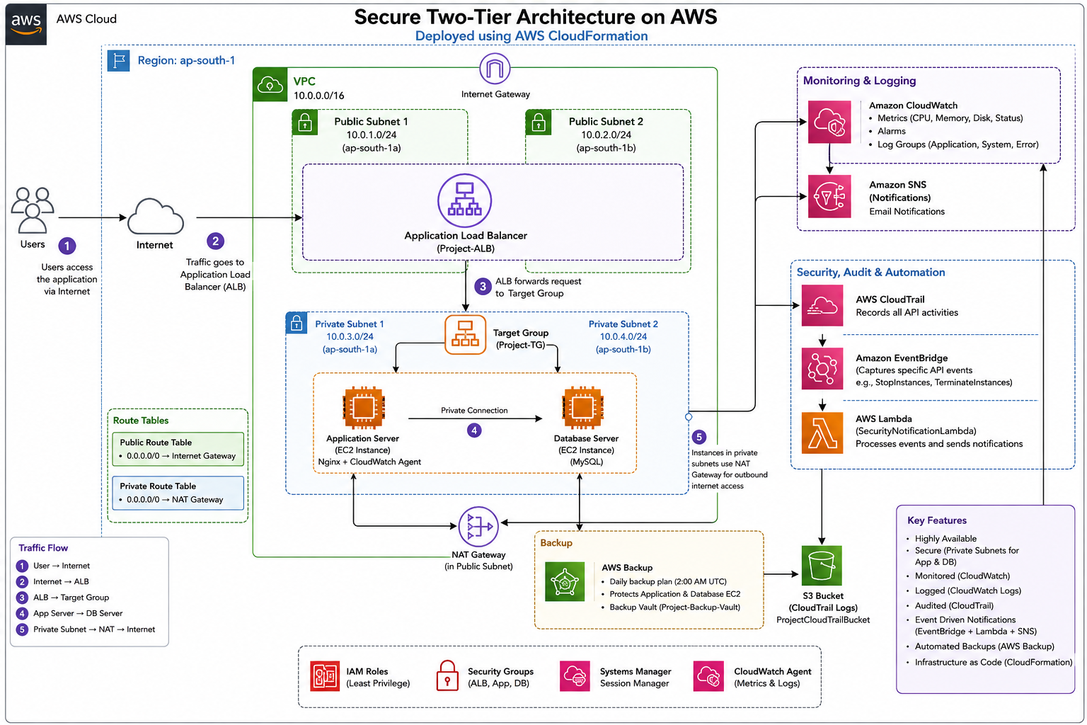

5. Implementation
- Created the infrastructure using AWS CloudFormation in YAML format.
- Uploaded the template and deployed it as a CloudFormation stack.
- CloudFormation automatically provisioned all AWS resources.
- Verified successful deployment with CREATE_COMPLETE status.
- Validated the deployed services, including ALB, EC2, CloudWatch, CloudTrail, Lambda, EventBridge, SNS, and AWS Backup.

6. Screenshots

1. CloudFormation Stack
- Stack Status = CREATE_COMPLETE

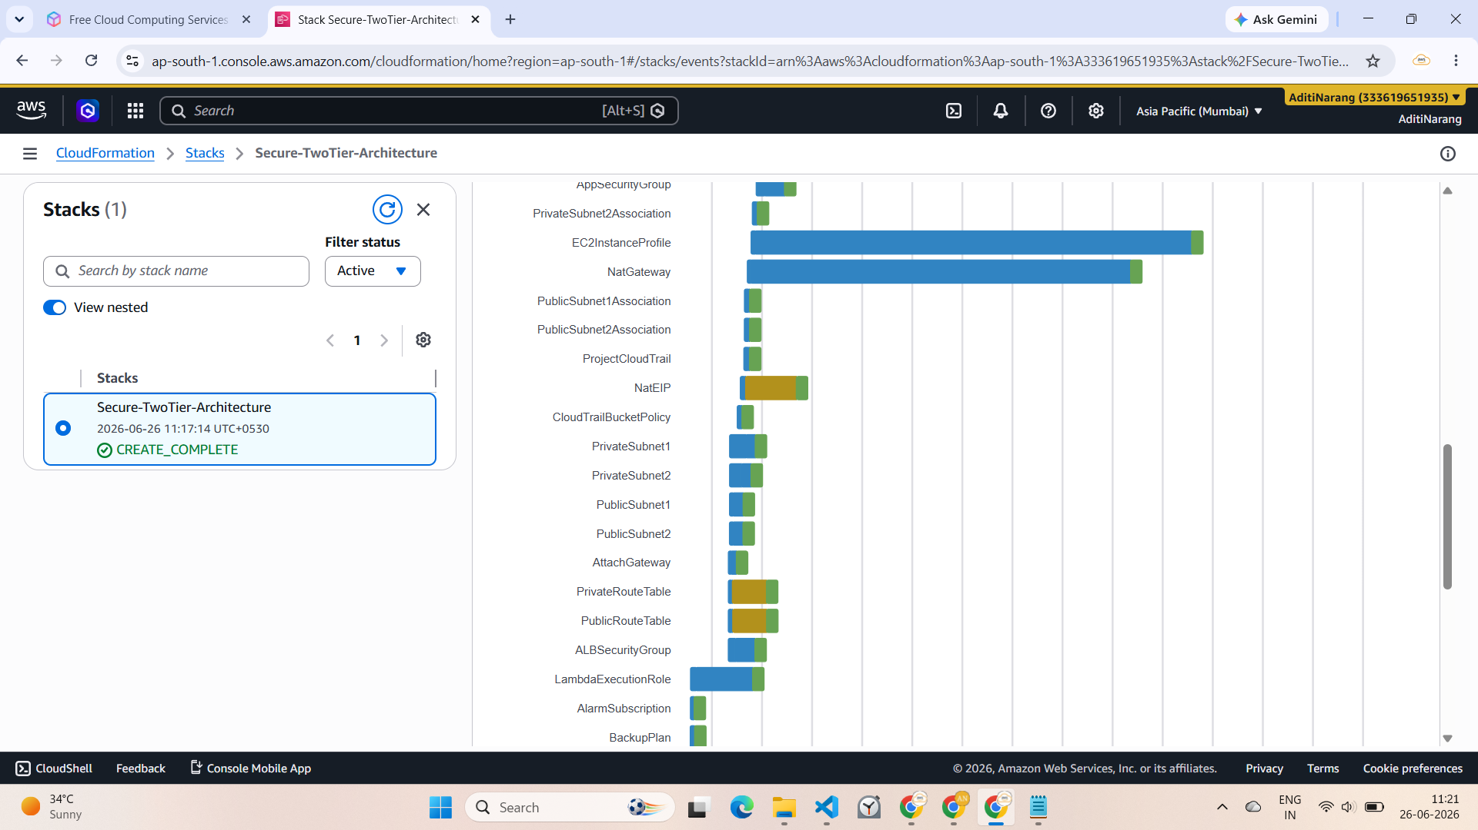

2. Resources Tab
All resources created:

2.1 VPC : (Project-VPC)
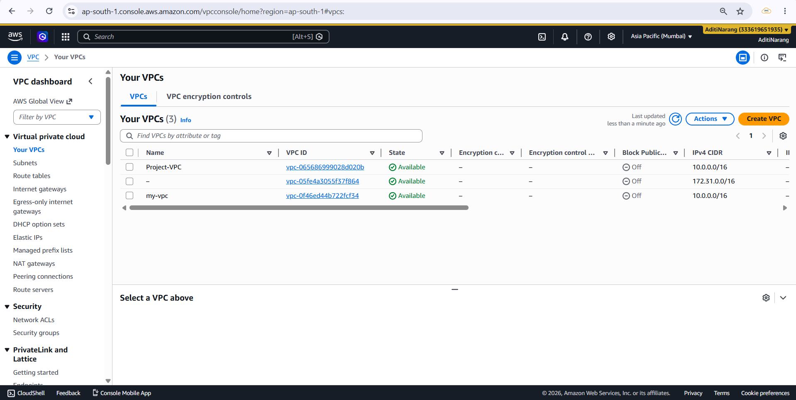

2.2 Resource Map:
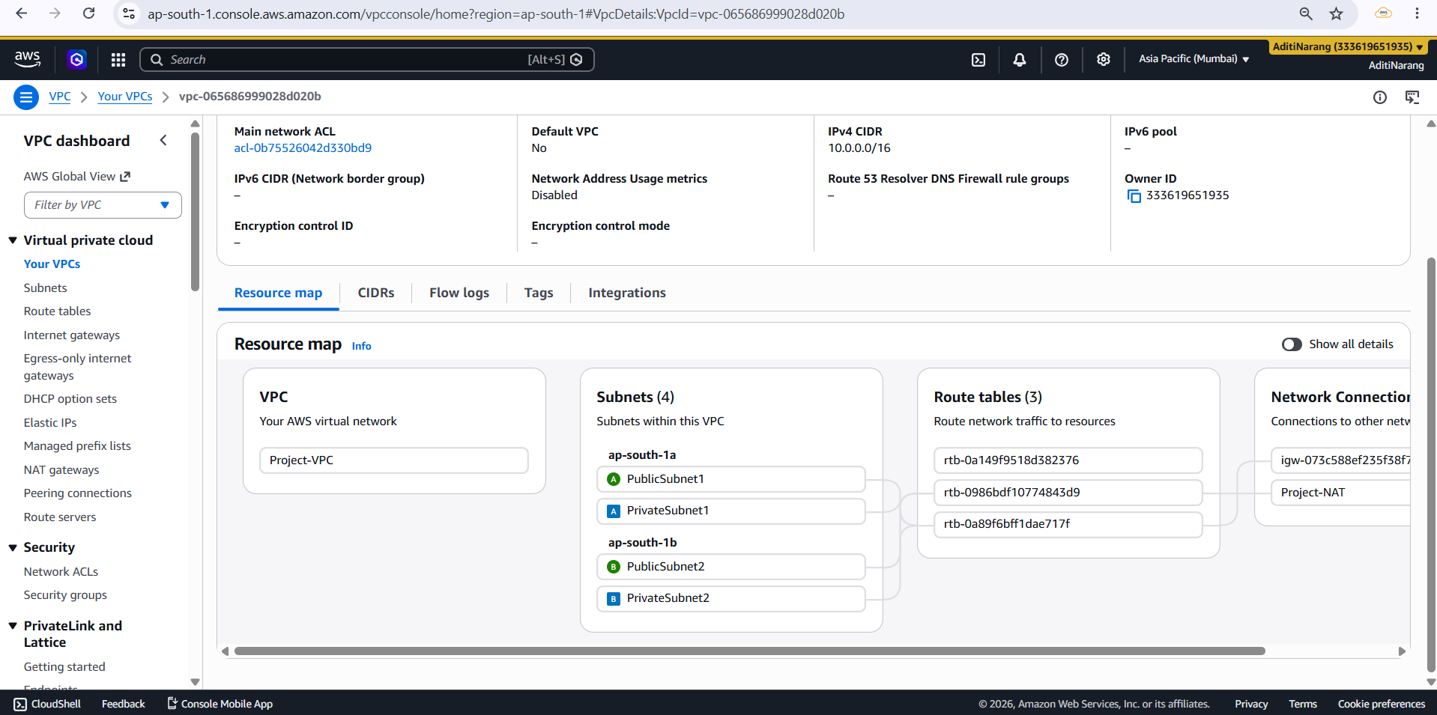

2.3 Public Subnet:
Public subnet routes internet-bound traffic through the Internet Gateway (Project-IGW).
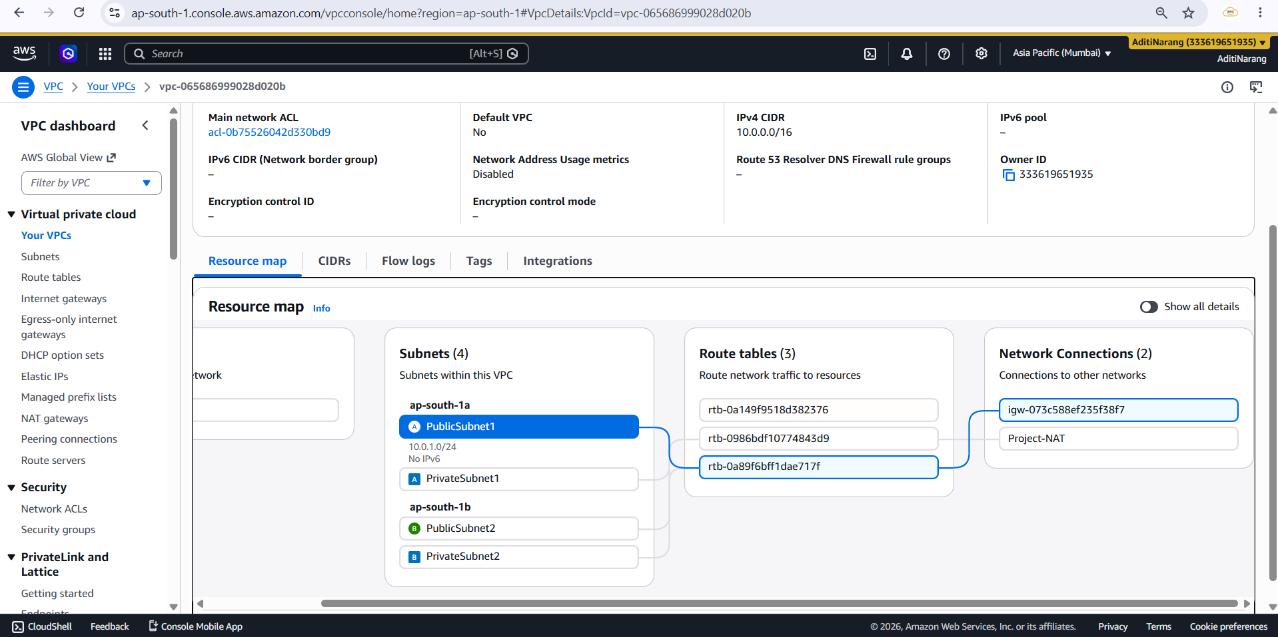

2.4 Private Subnet:
Private subnet routes outbound traffic through the NAT Gateway (Project-NAT).
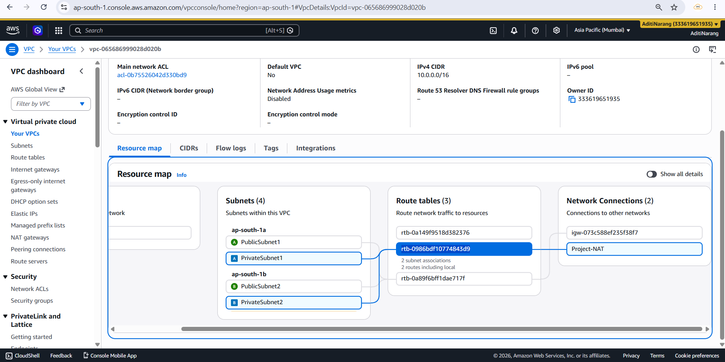

2.5 Route Table:
Rouble table for public instance and public subnet :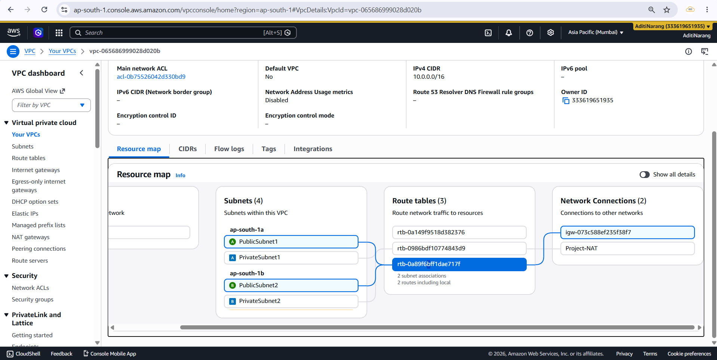

Rouble table for private instance and private subnet :
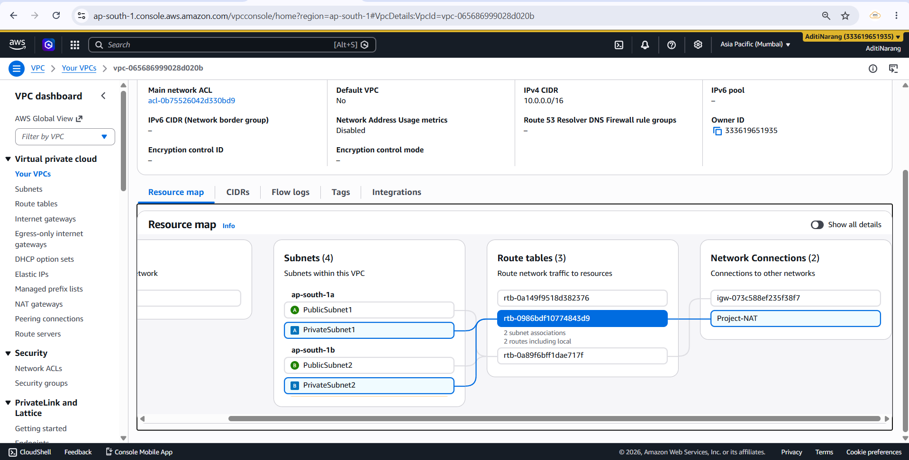

2.6 Internet Gateway:
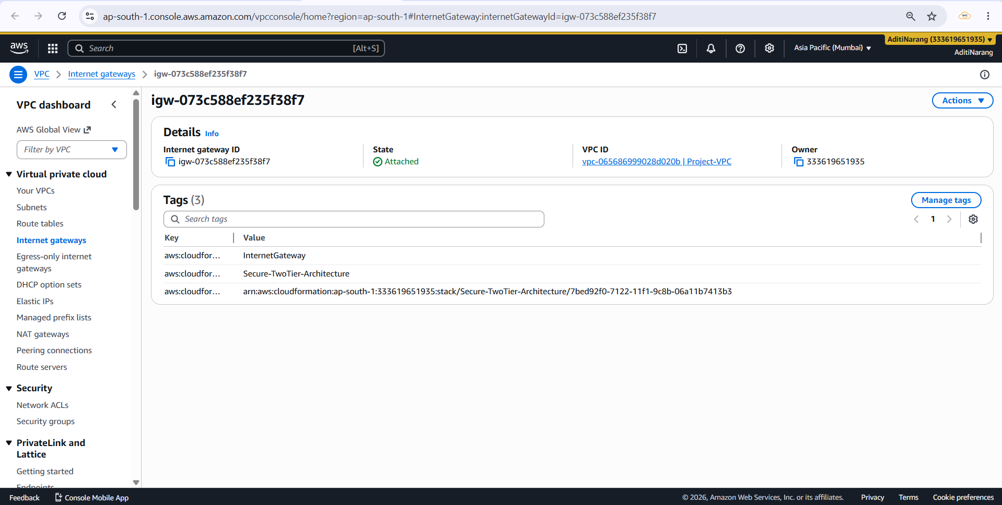

2.7 NAT Gateway:
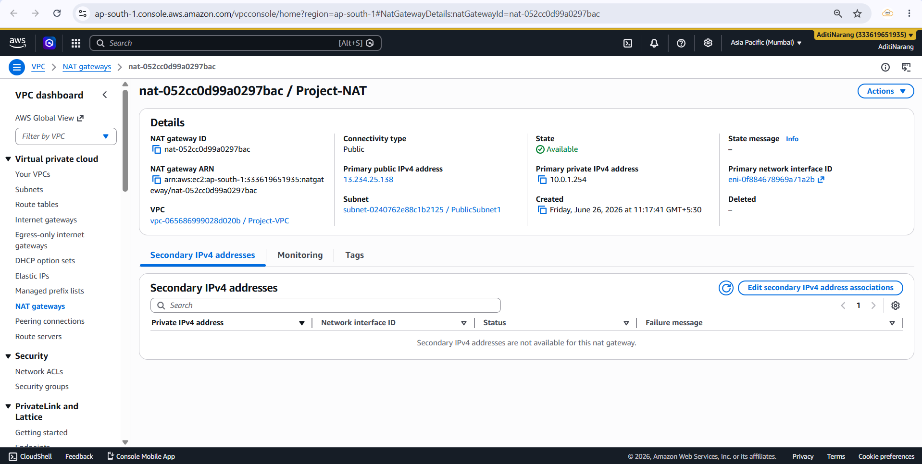

2.8 Security Group:
Application Load Balancer-SecurityGroup
Application-SecurityGroup
Database-SecurityGroup
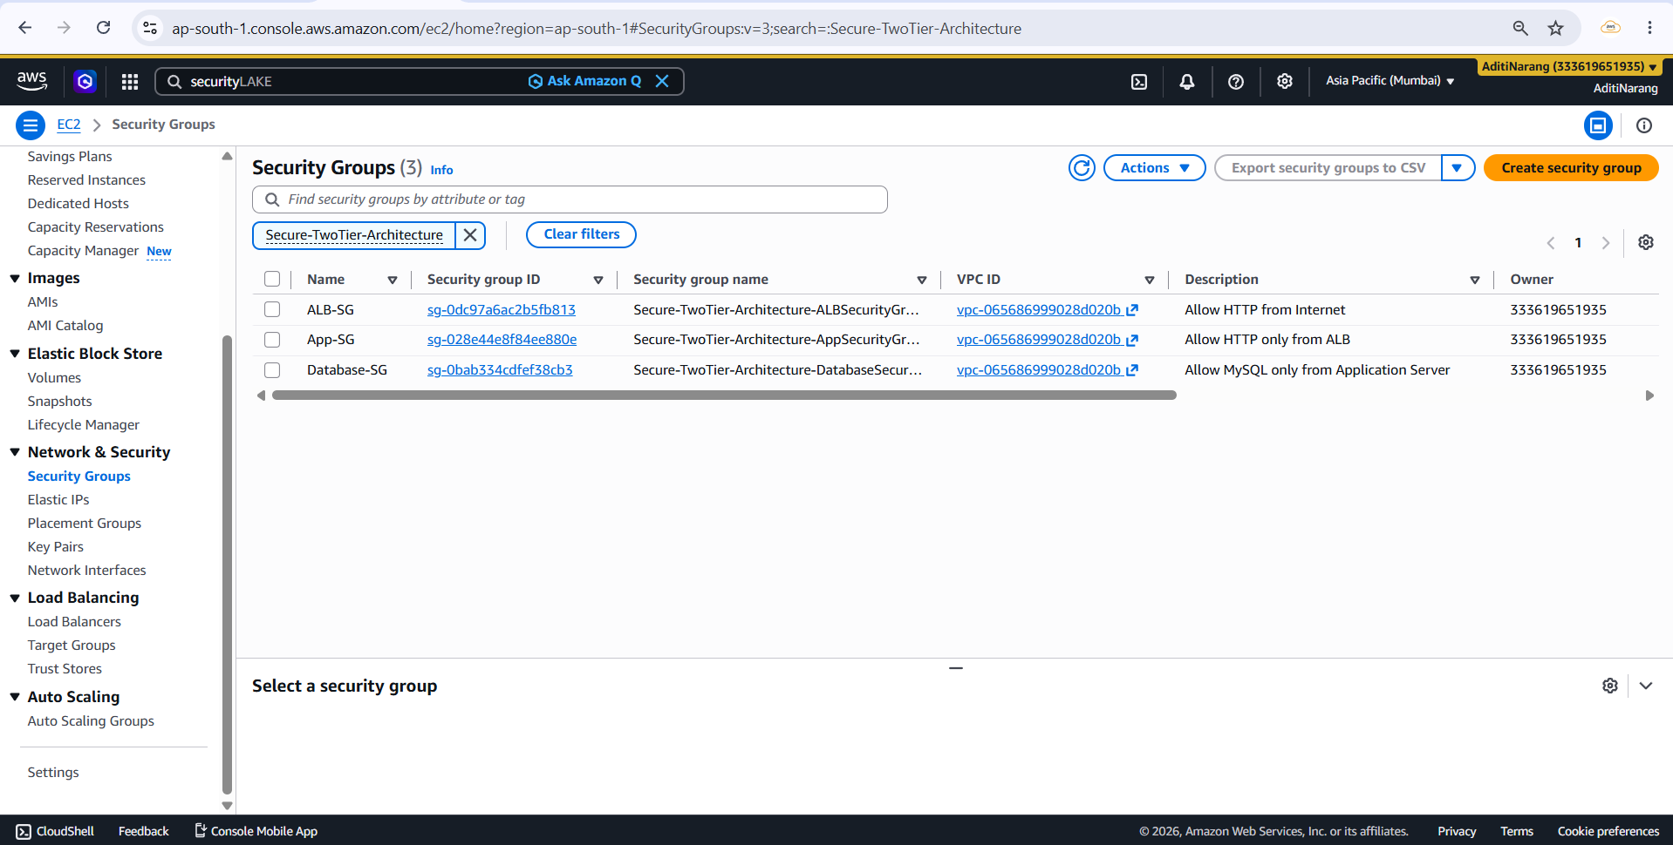

2.9 Target Group:
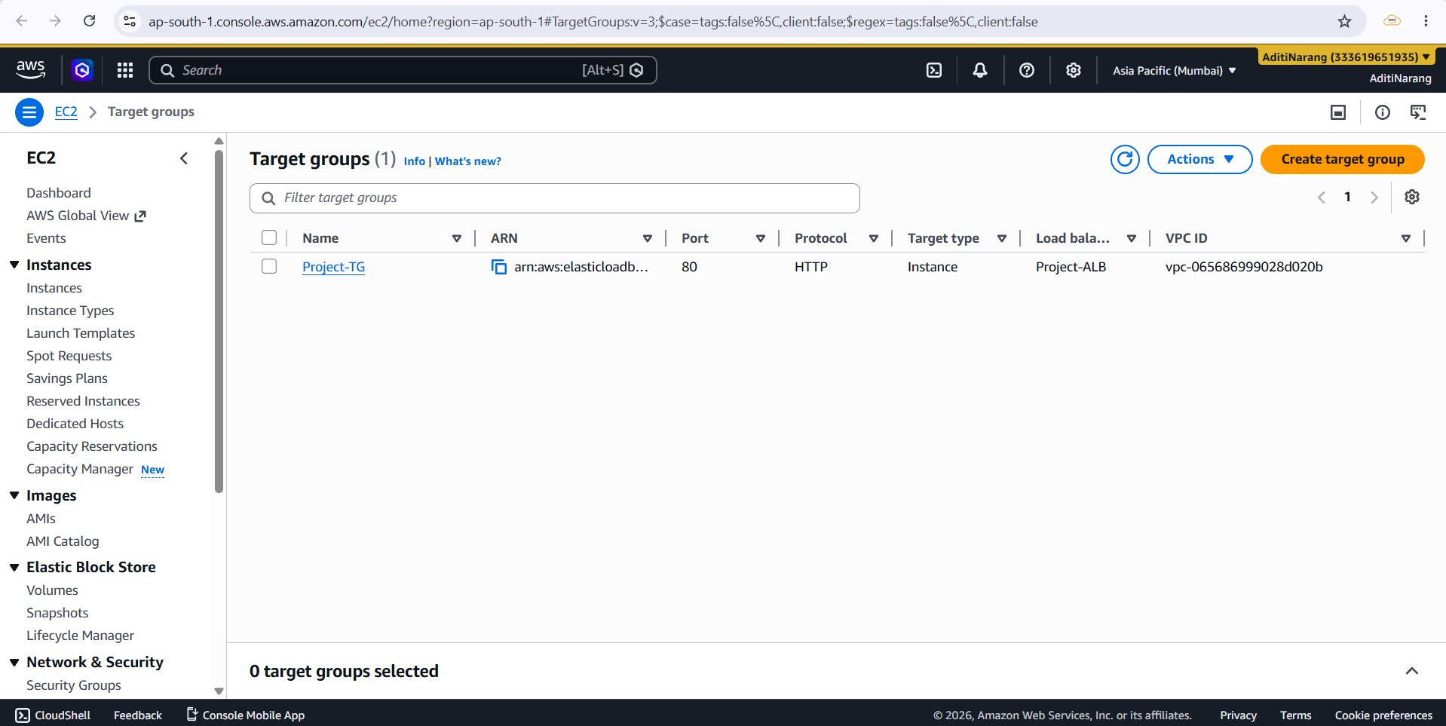

(Healthy):
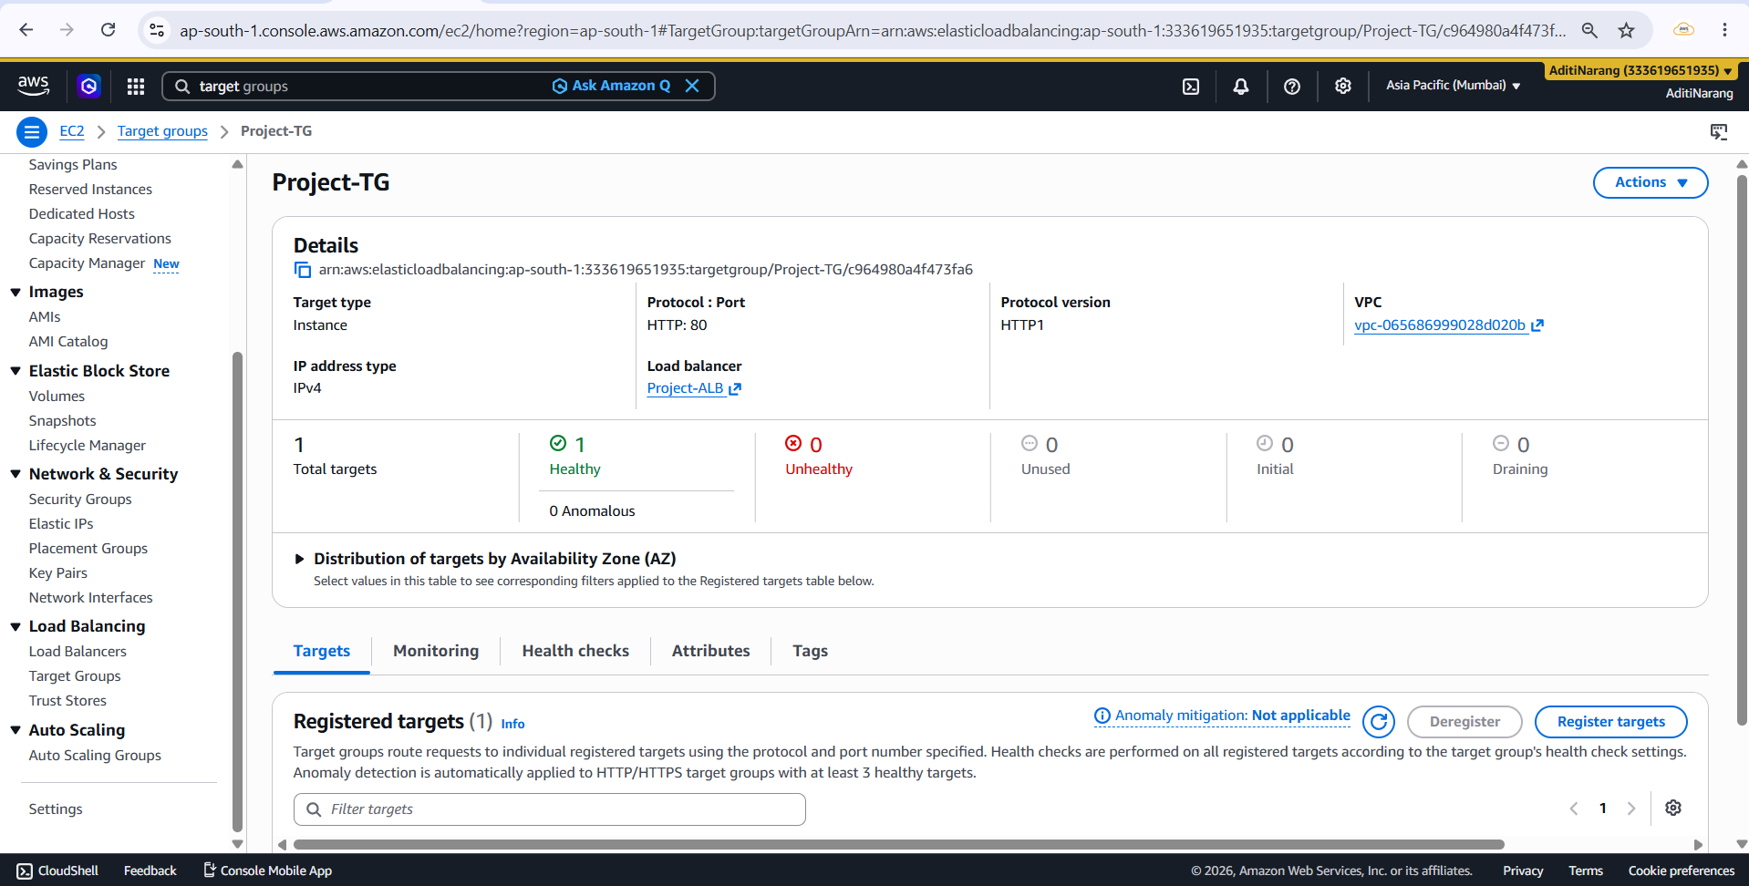

2.10 Load Balancer:
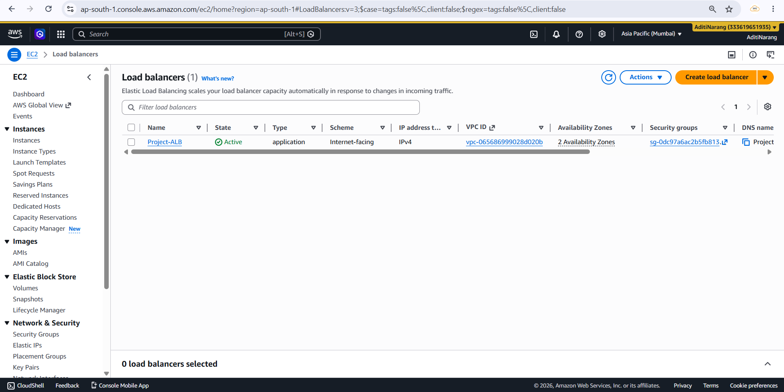

(Project-ALB) and Resource Map:
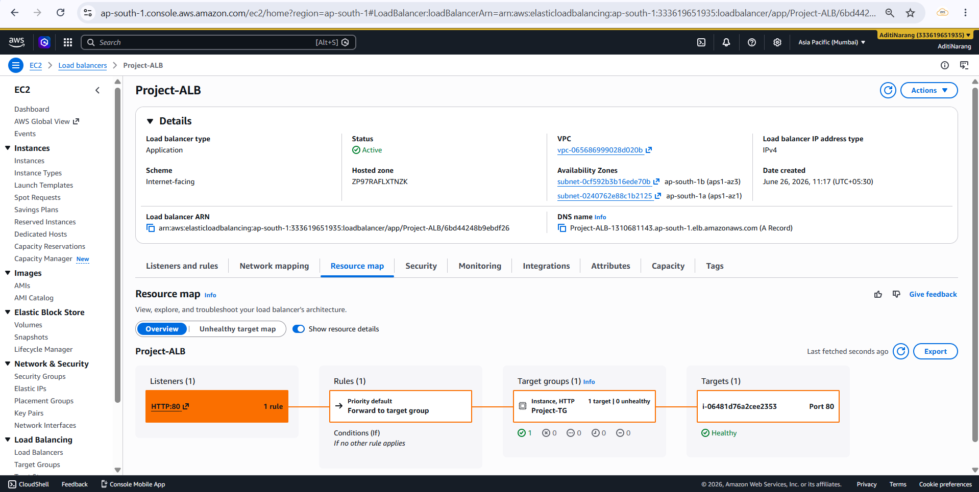

2.11 Browser:
Open: http://project-alb-1310681143.ap-south-1.elb.amazonaws.com/
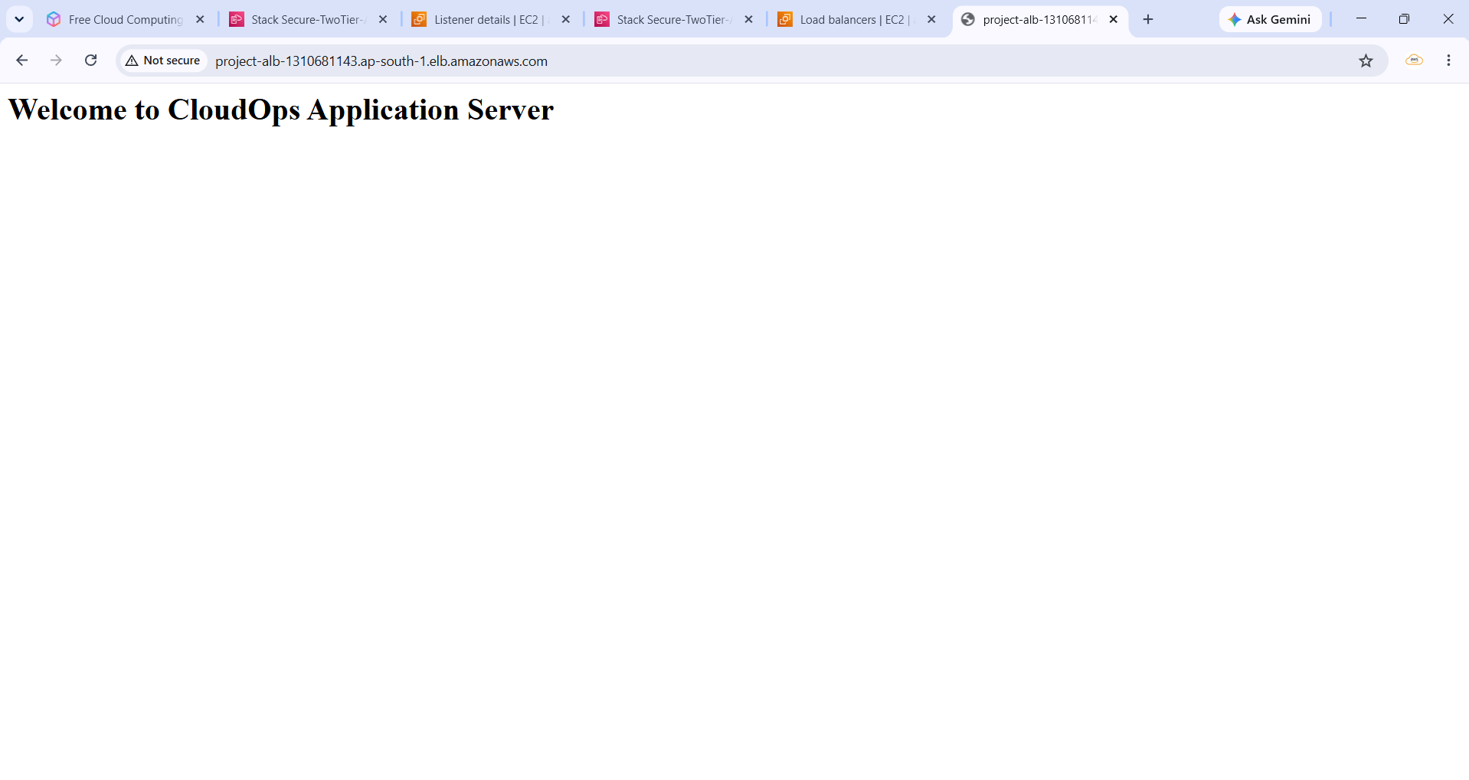

2.12 SSM Managed Instances
1. Application-Server : (Public Instance in Public subnet)
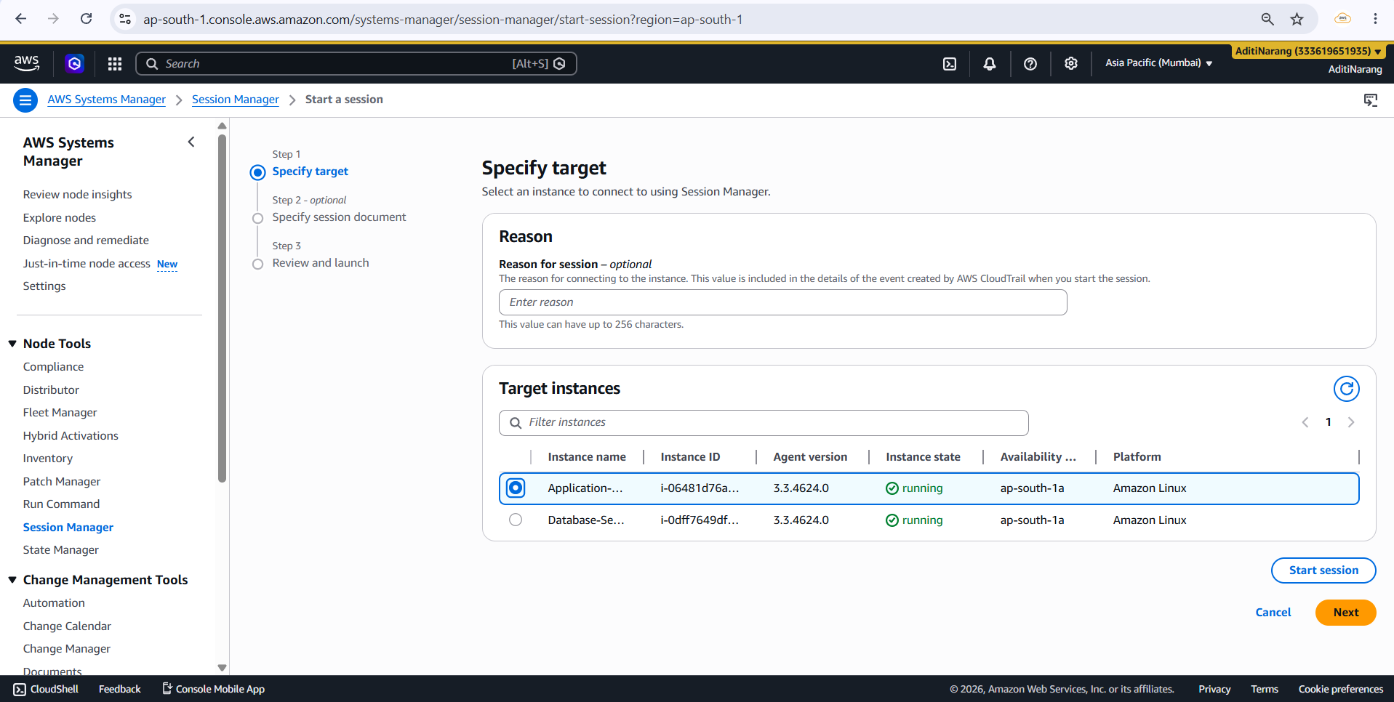
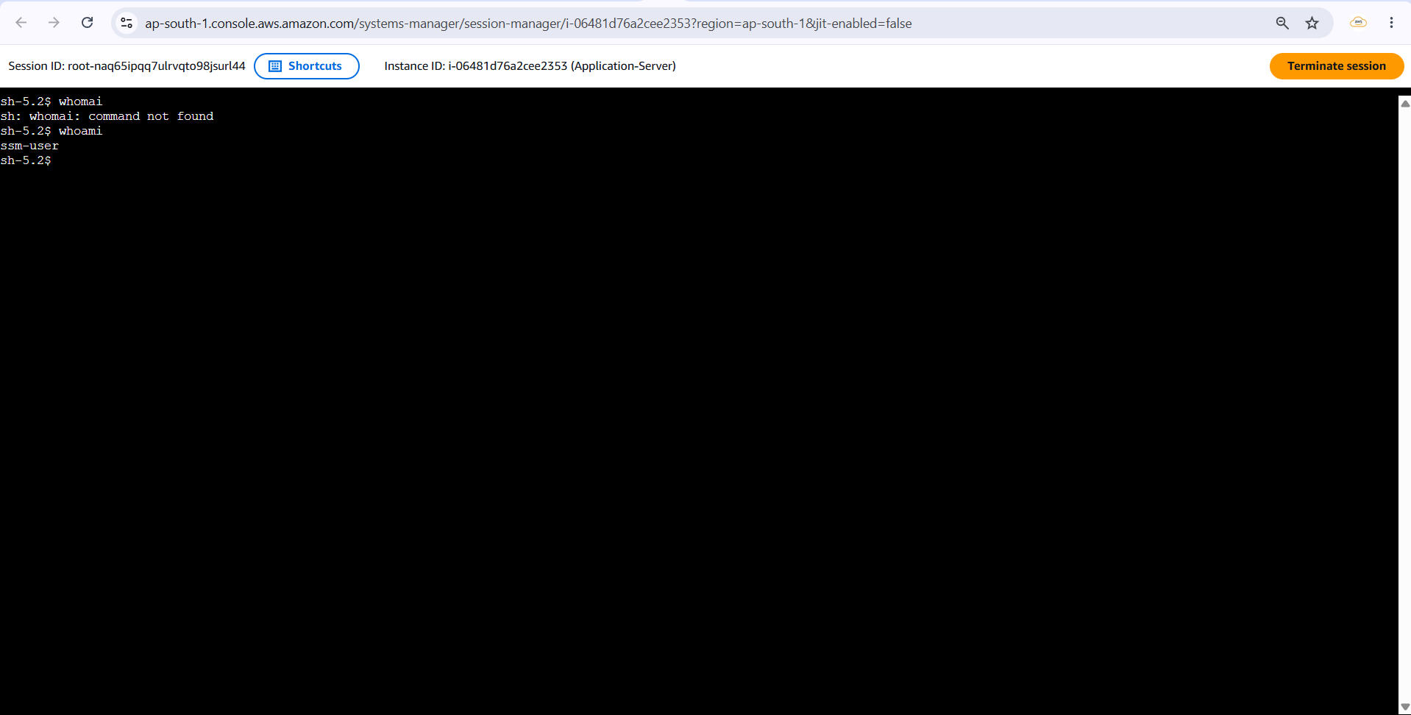
2. Database-Server: (Private Instance in Private Subnet)
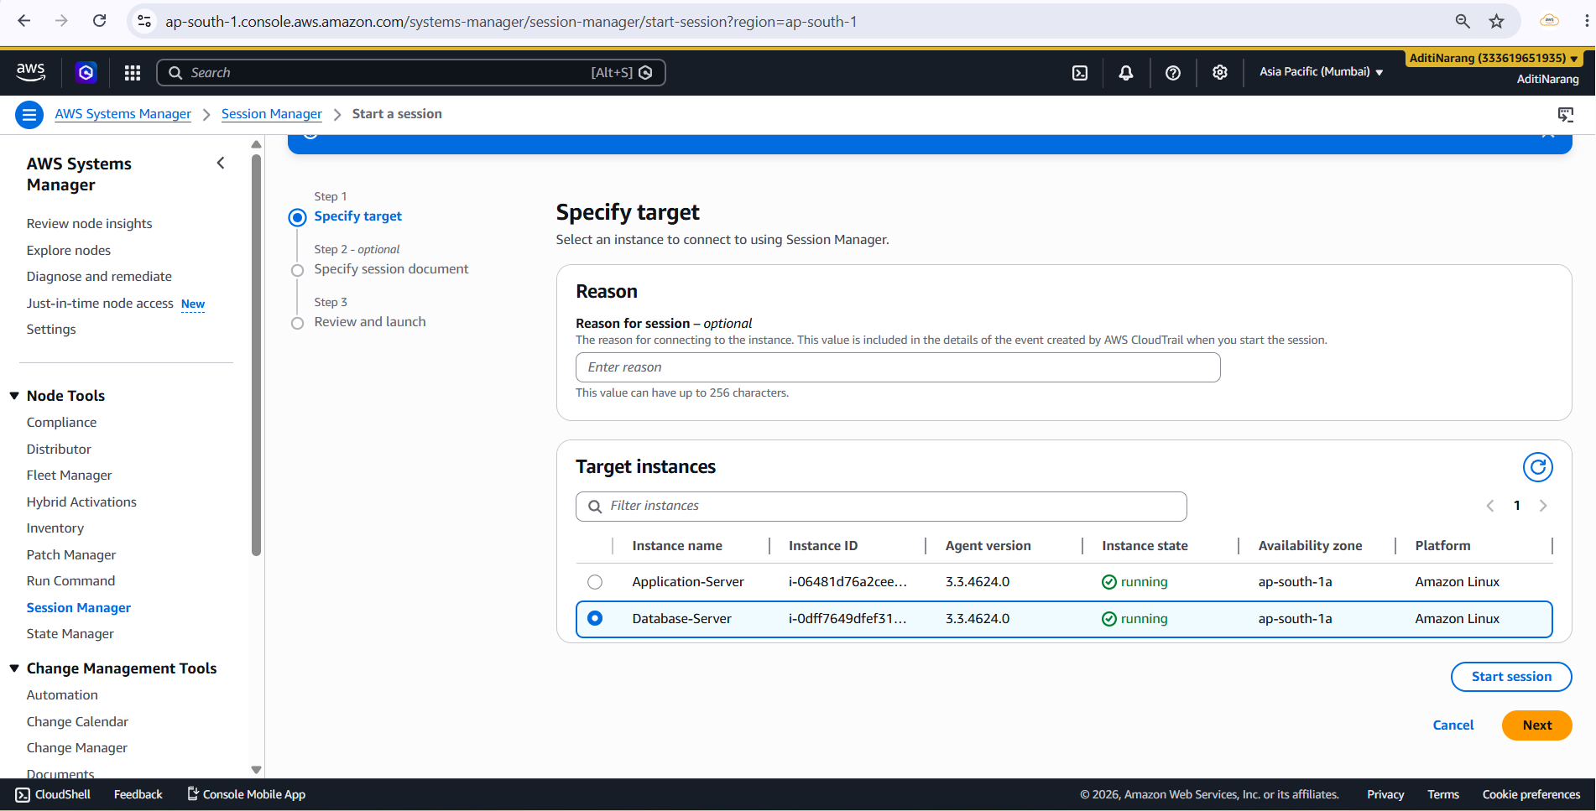
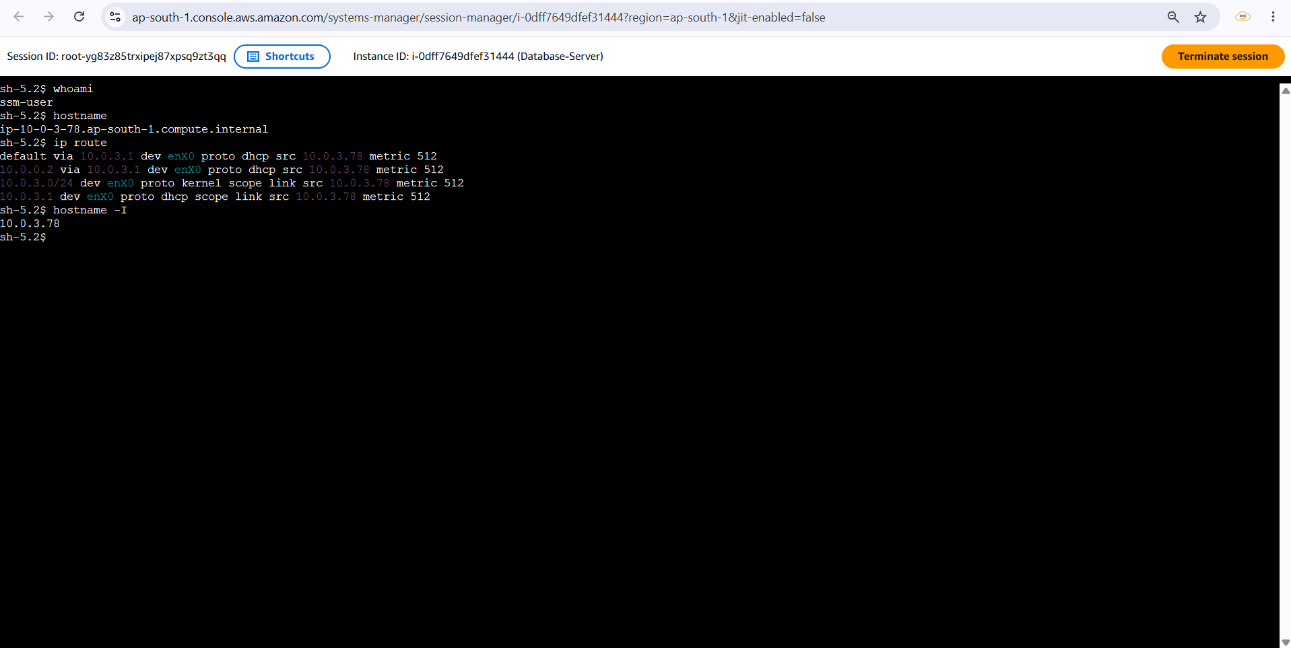

2.13 S3 Bucket:
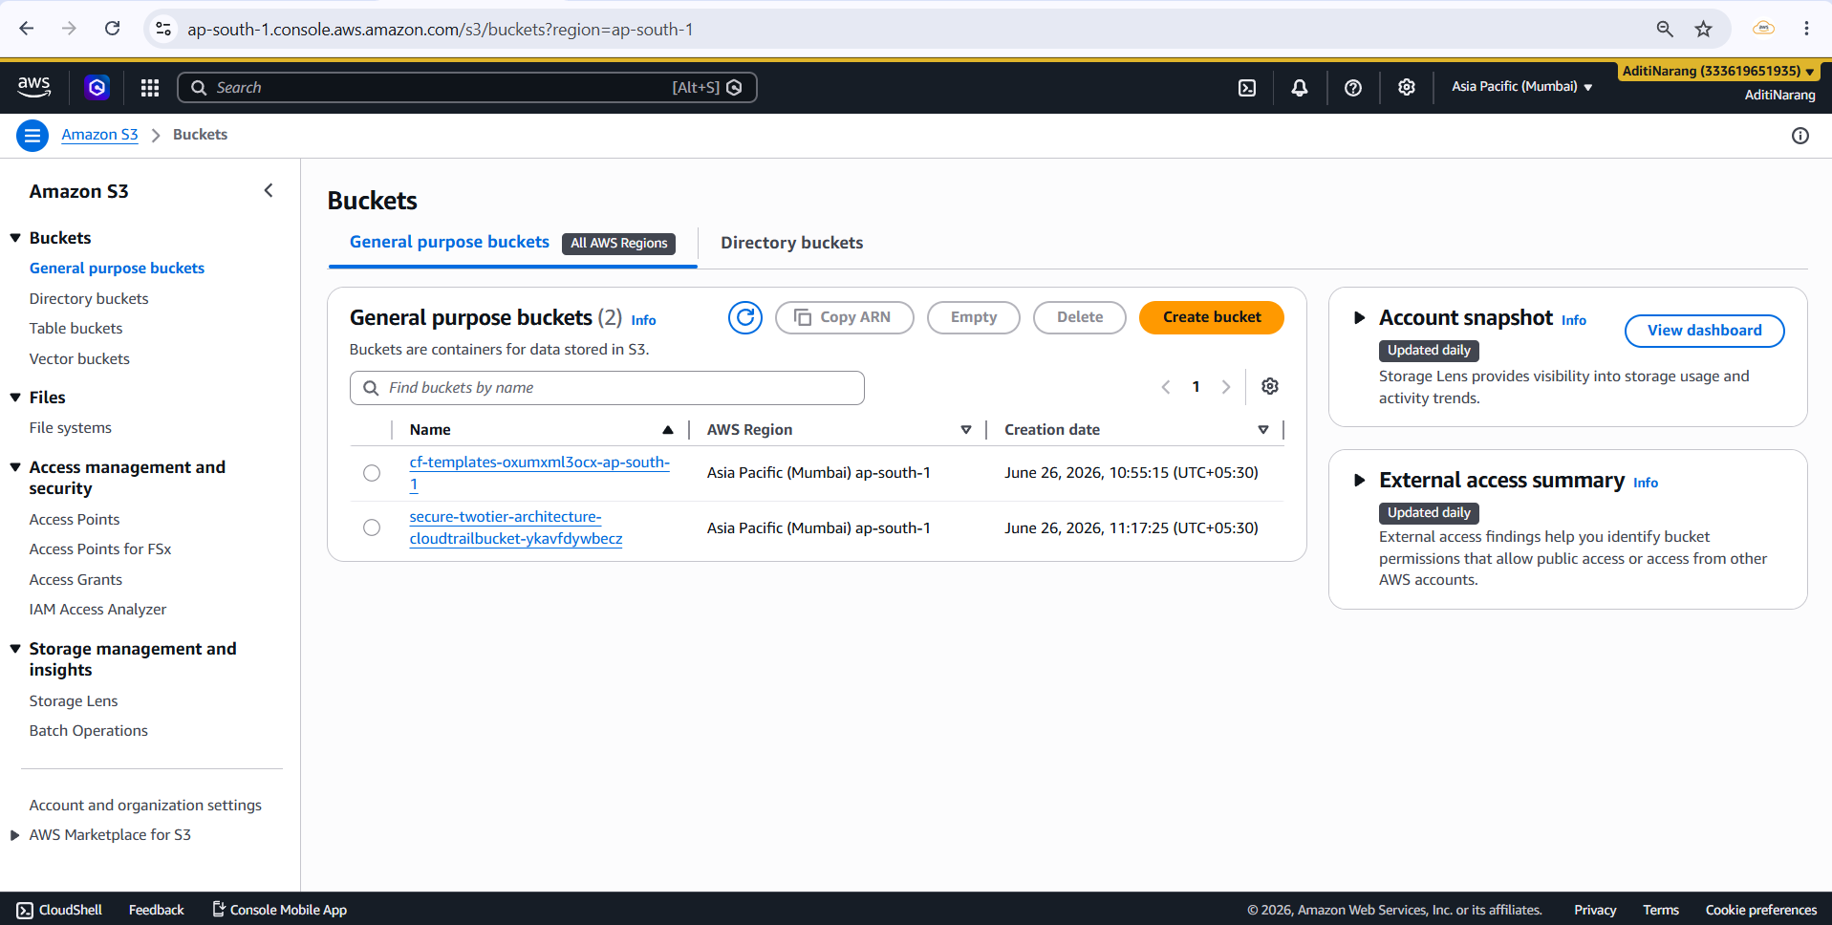

CloudTrail logs stored in the S3 bucket:
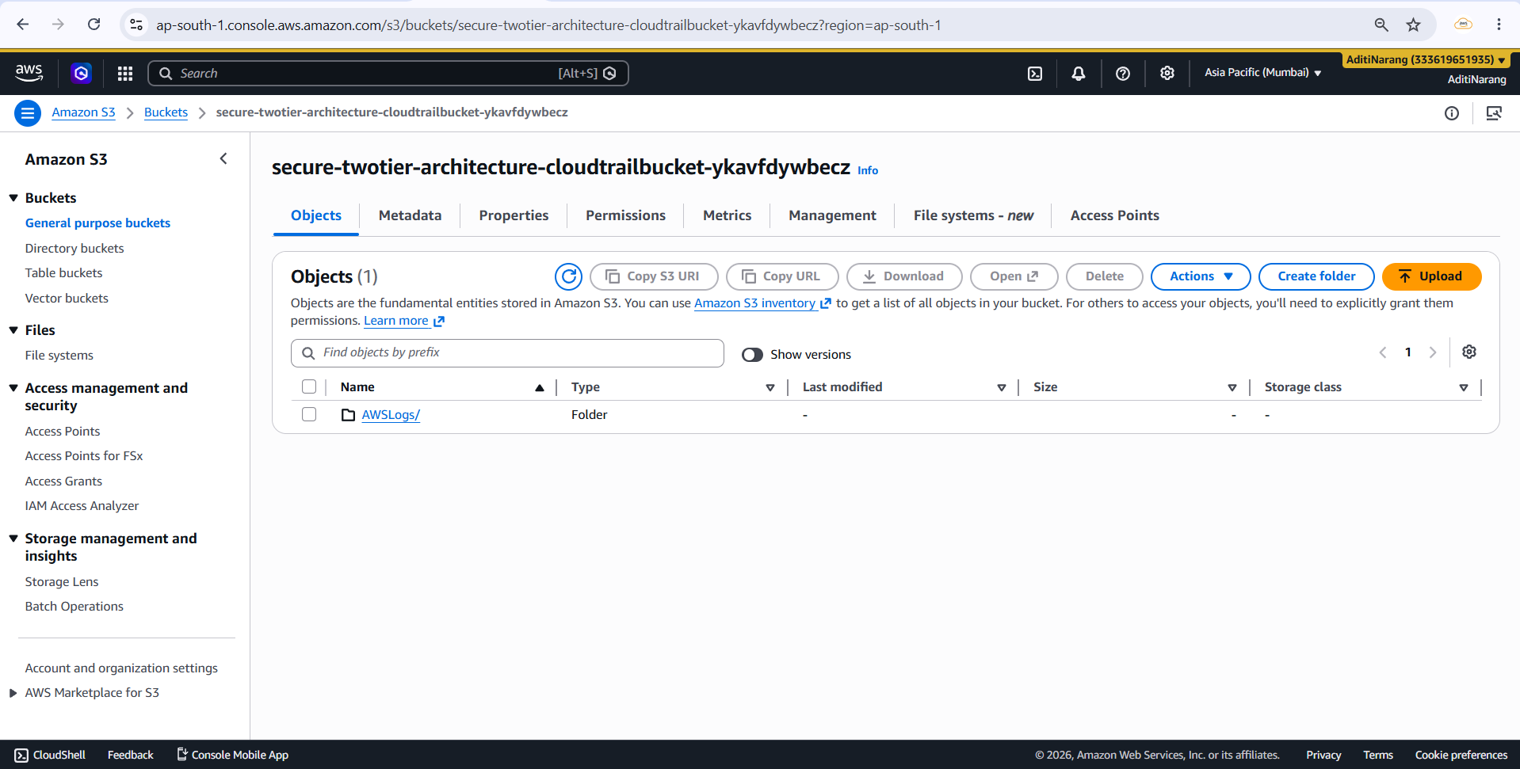

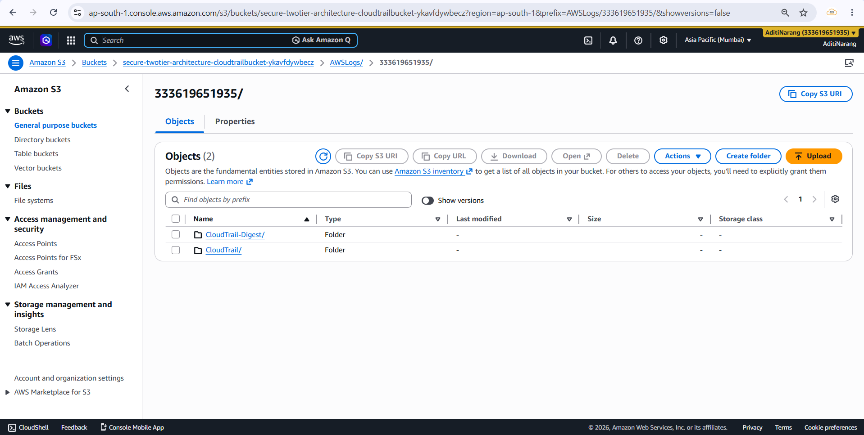

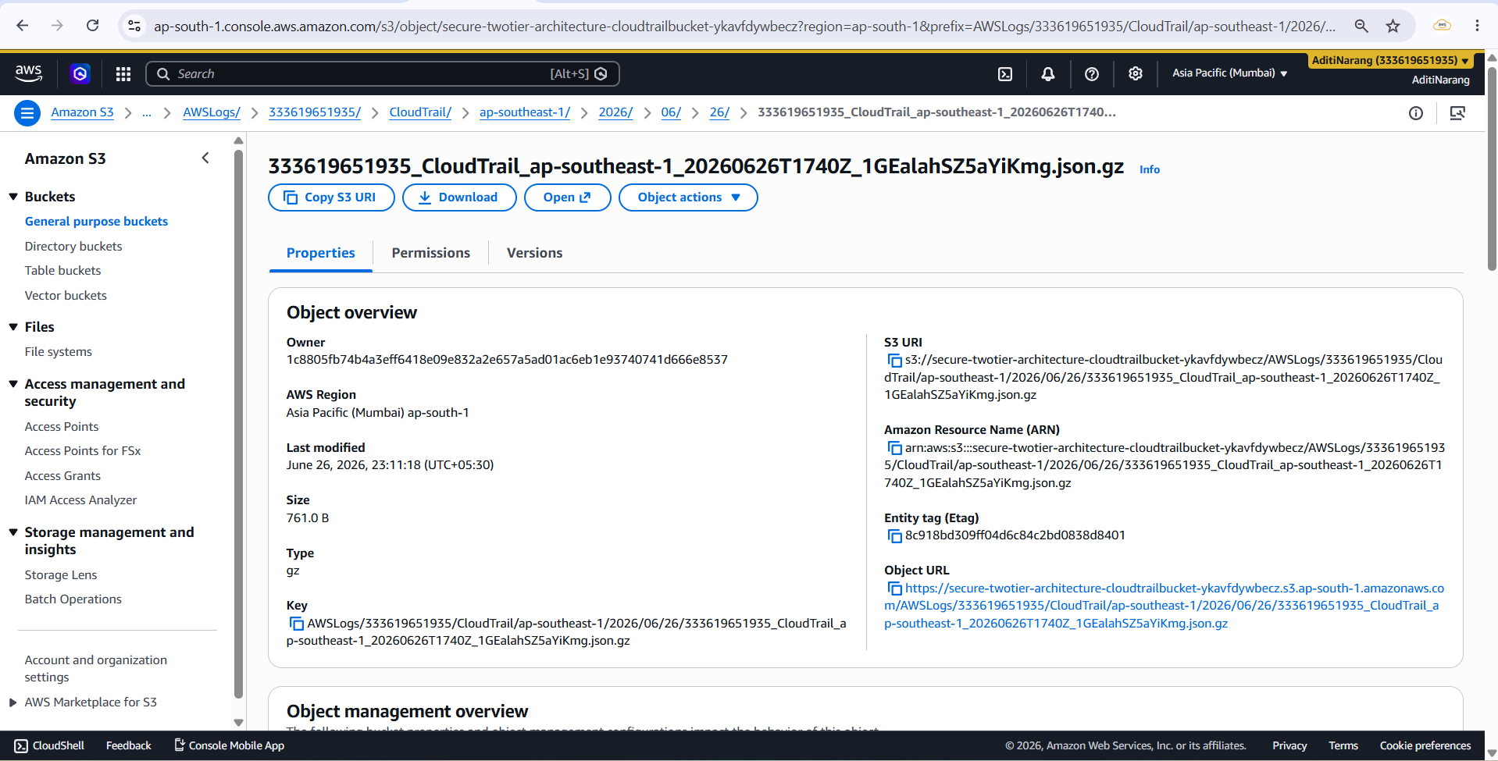

2.14 Lambda:
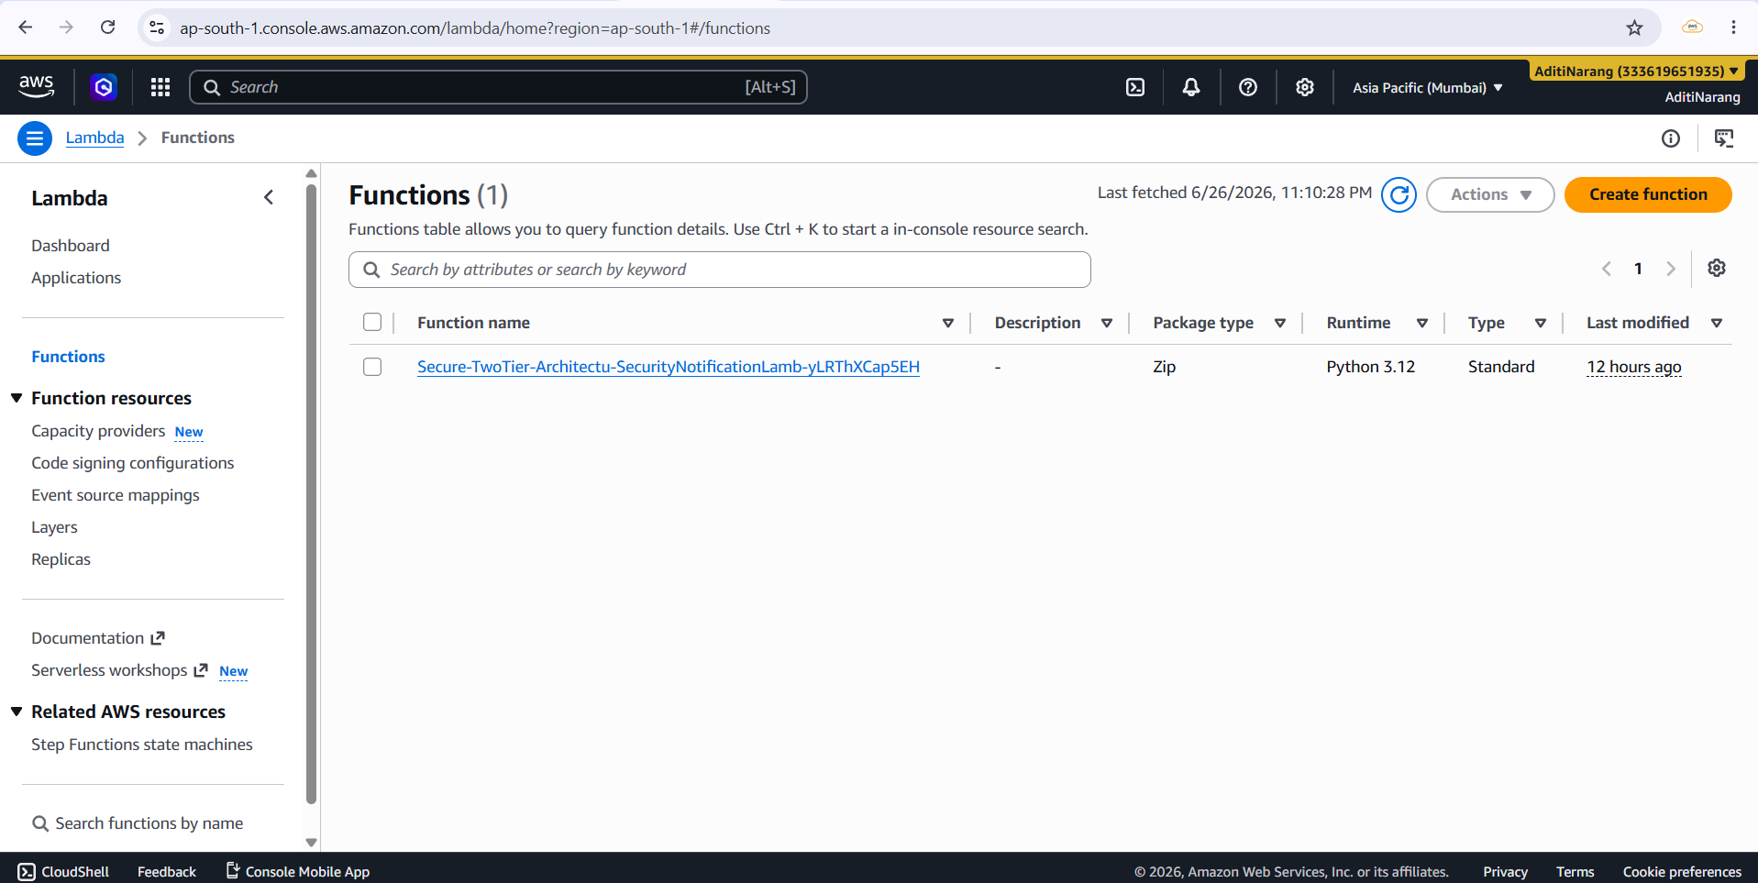

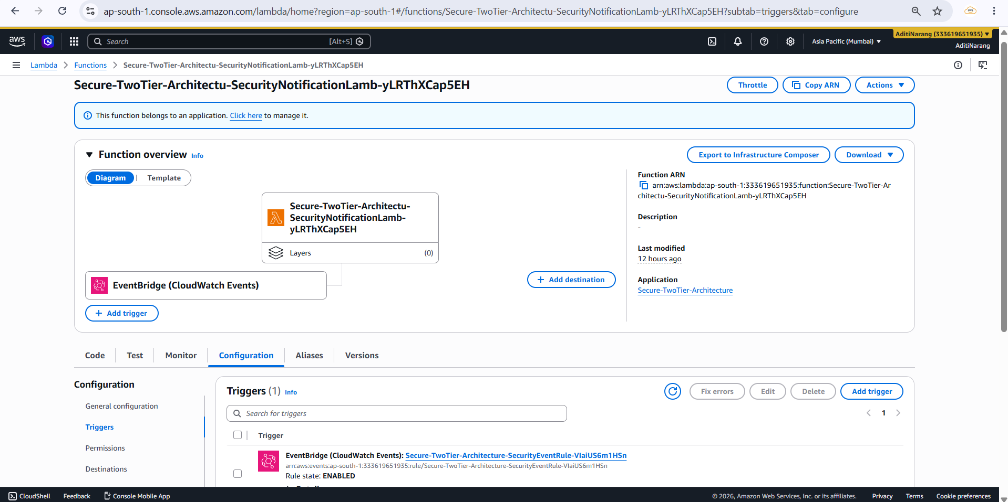

2.15 EventBridge:
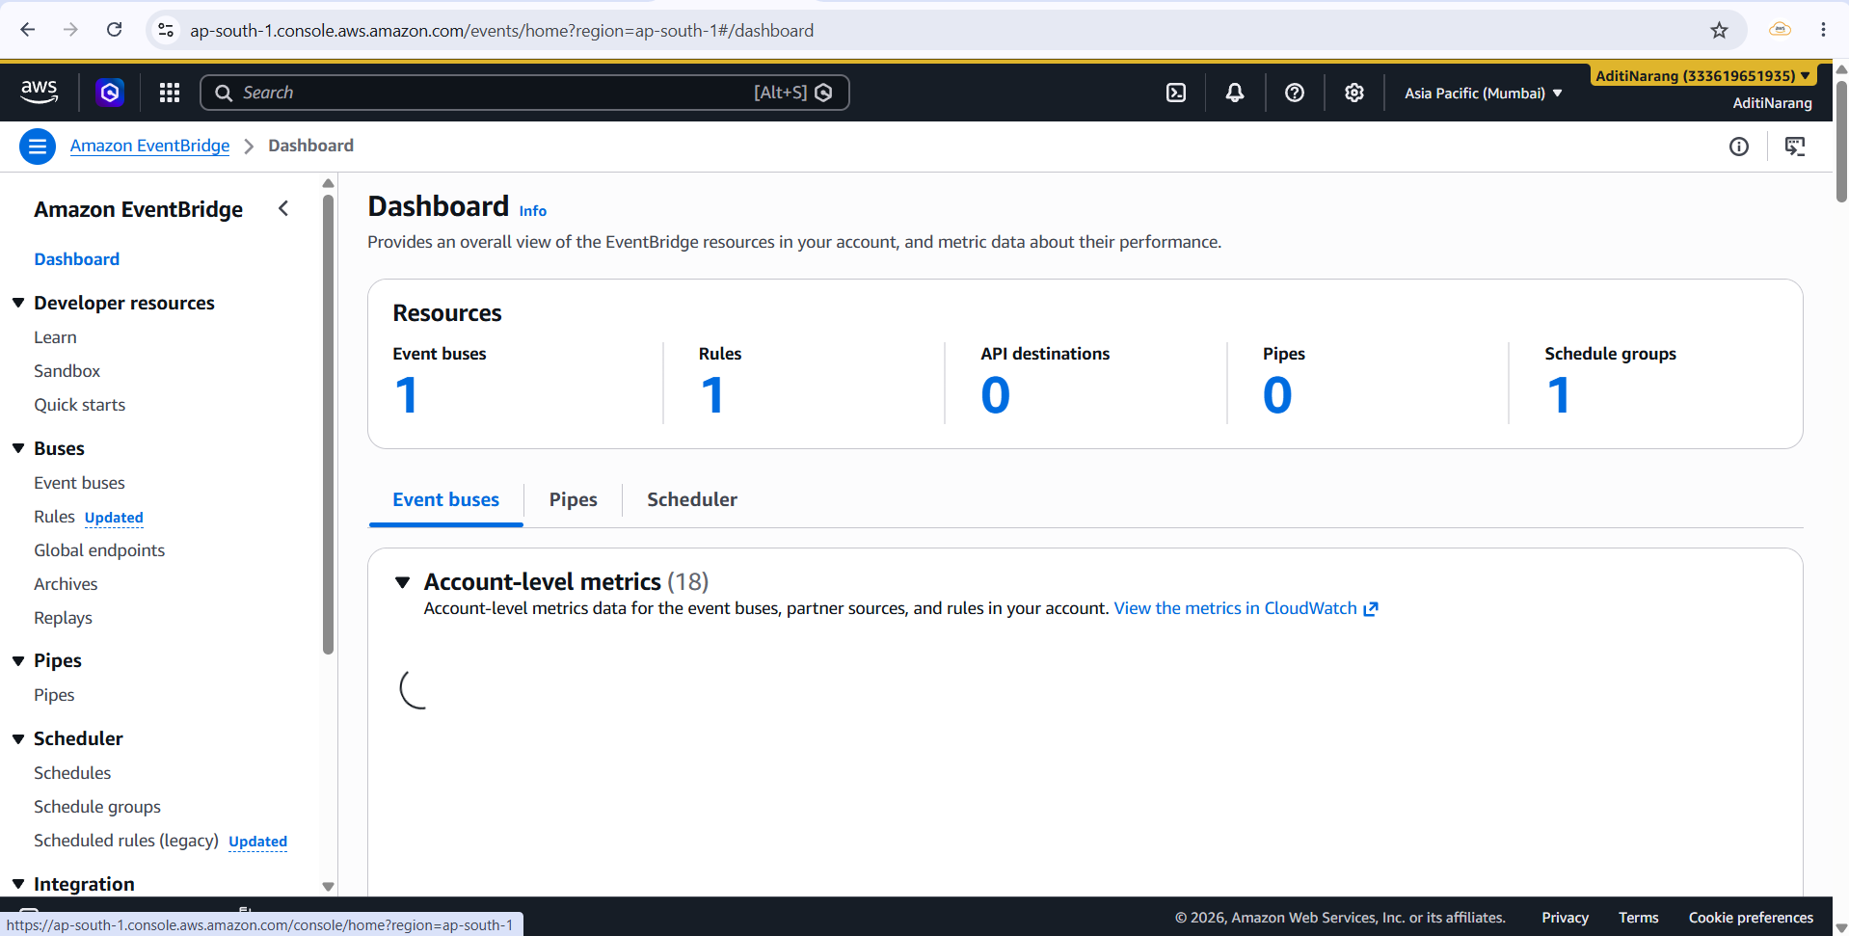

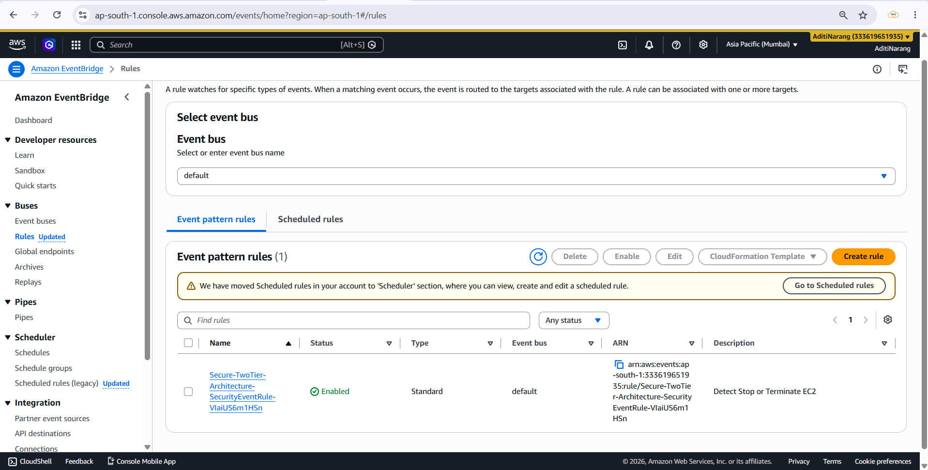

2.16 AWS Backup:
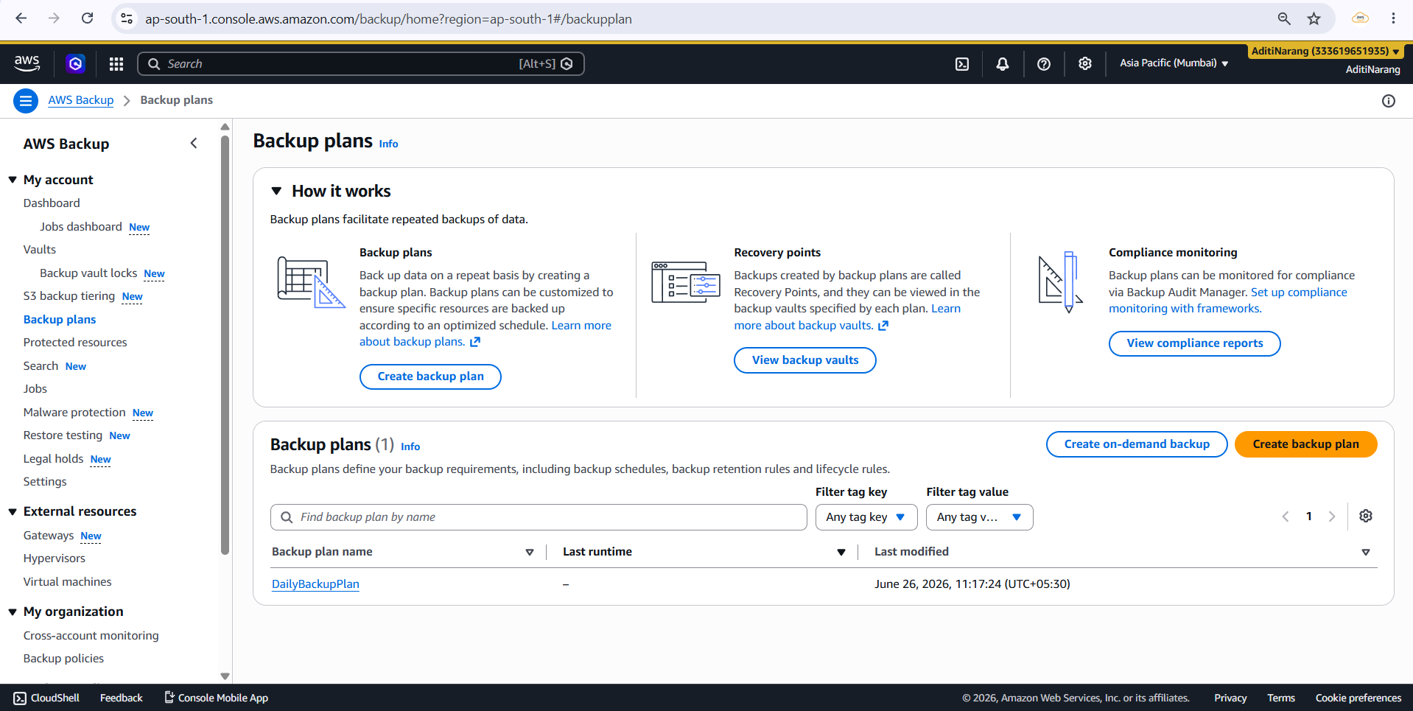

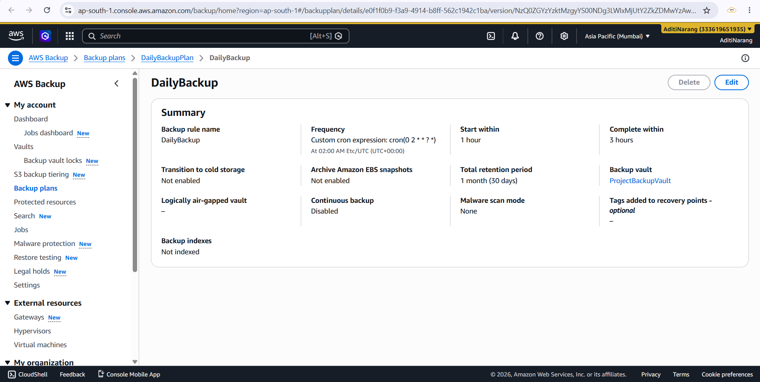

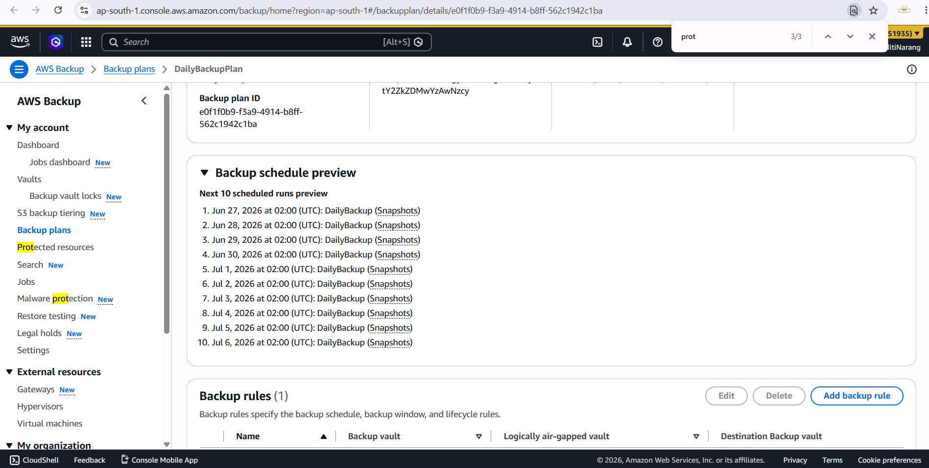

2.17 CloudWatch:
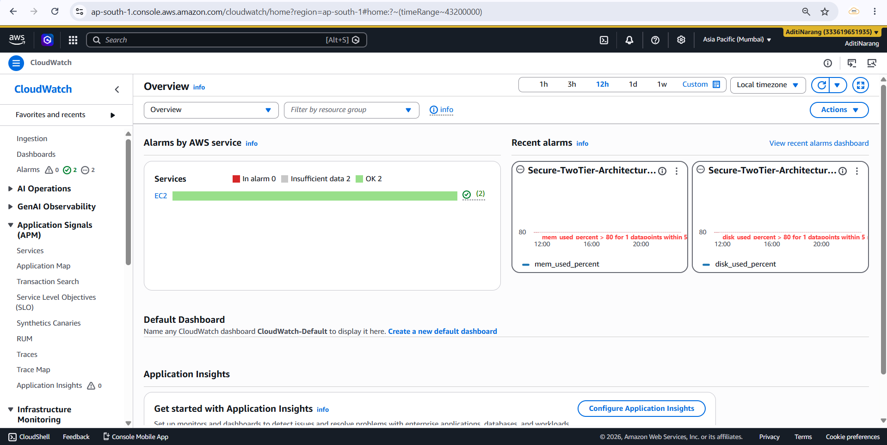

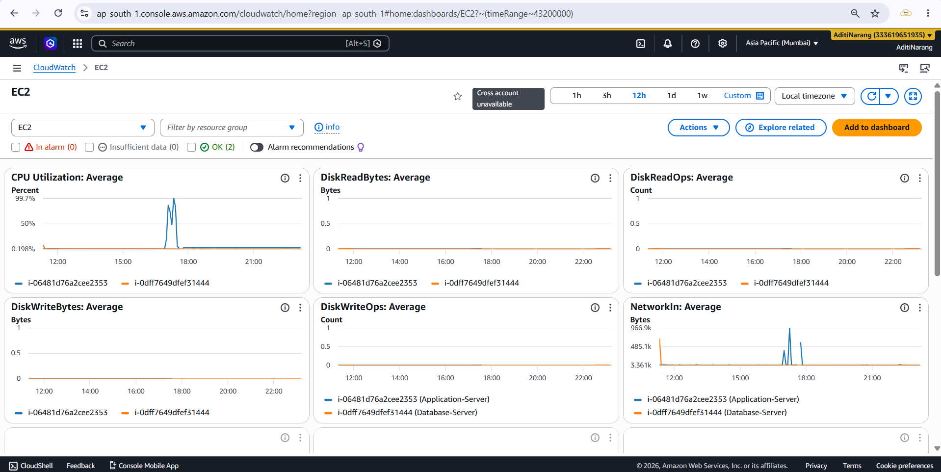

Monitoring (Metrics):
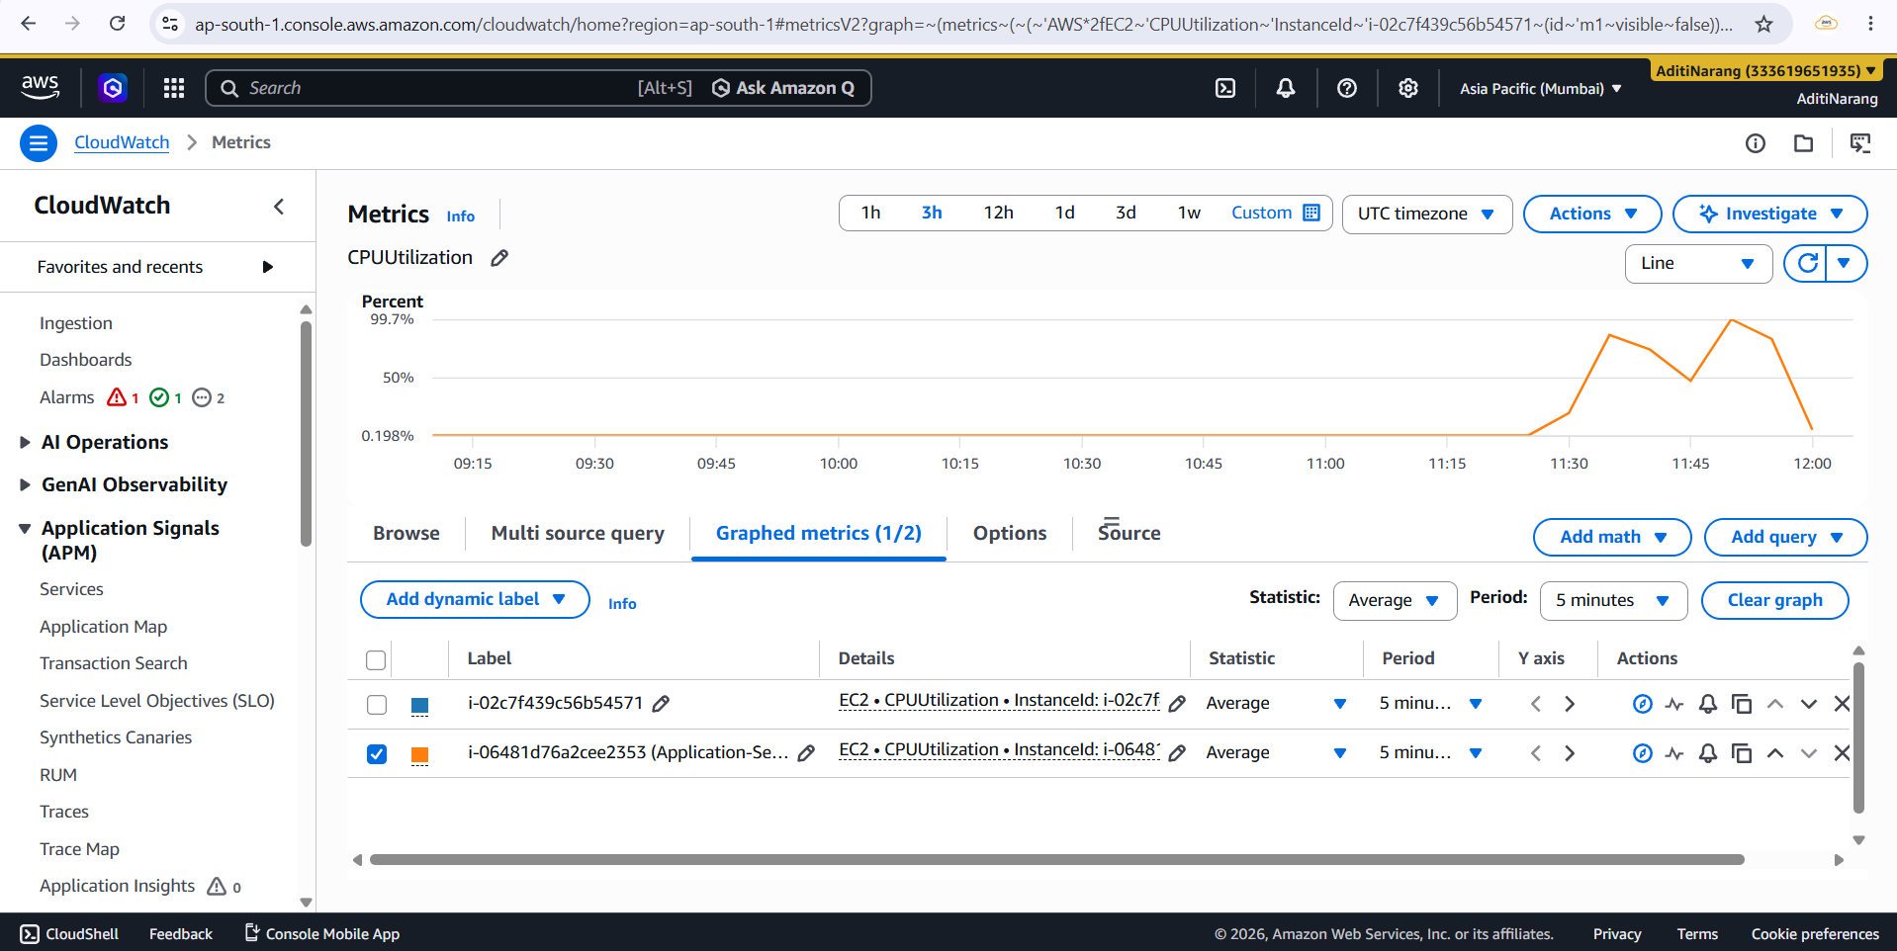

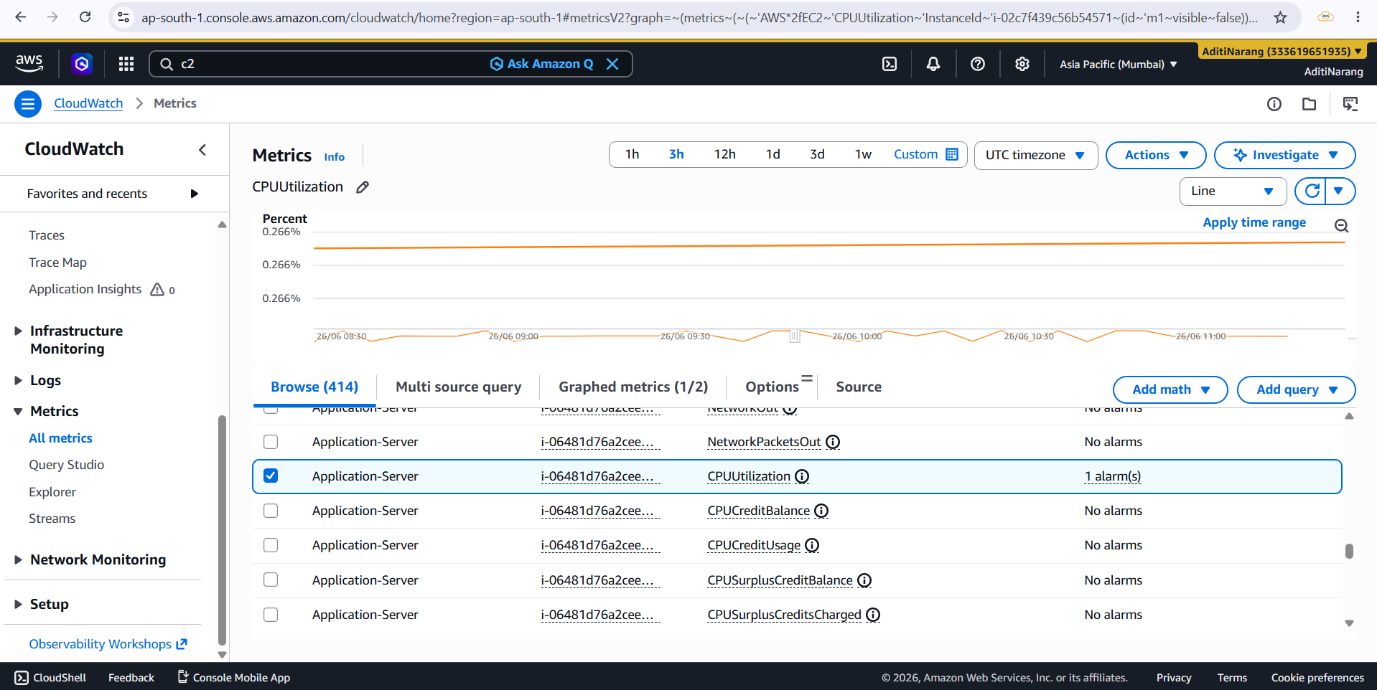

Logs:
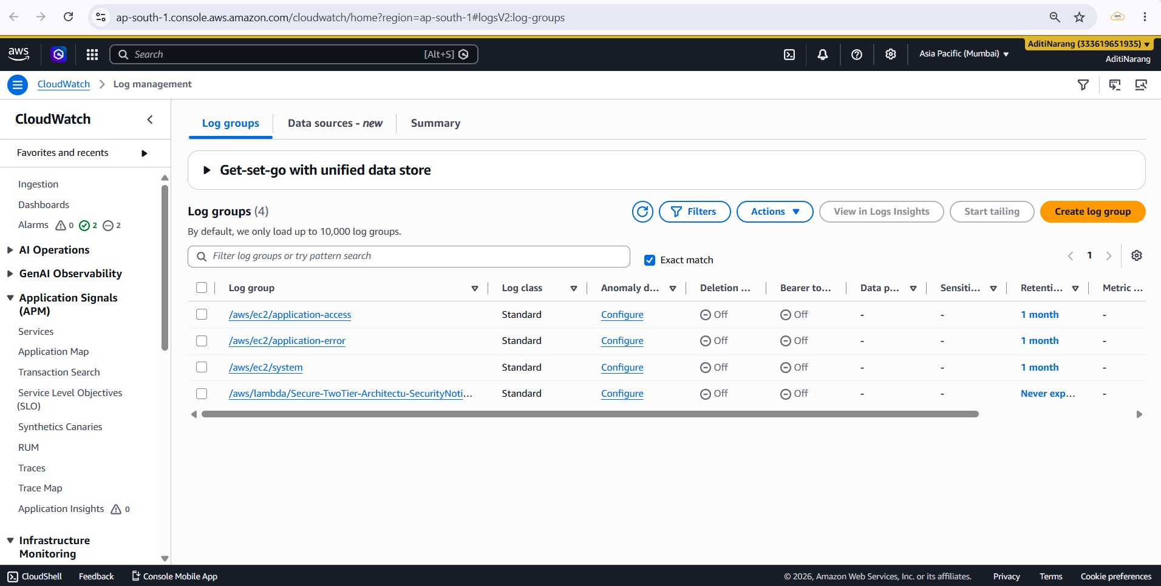

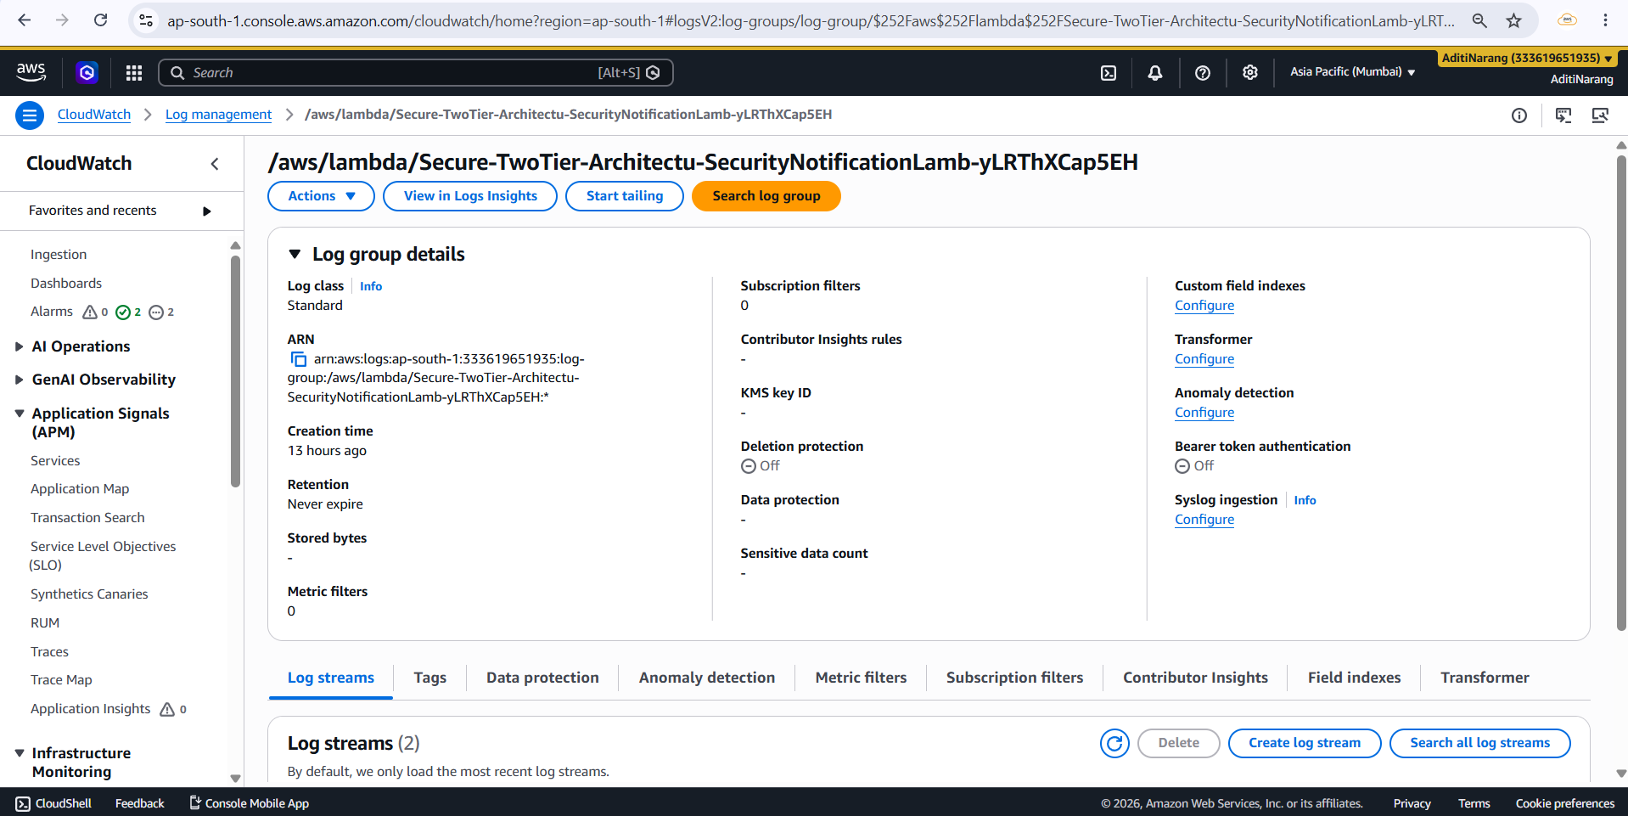

2.18 CloudTrail:
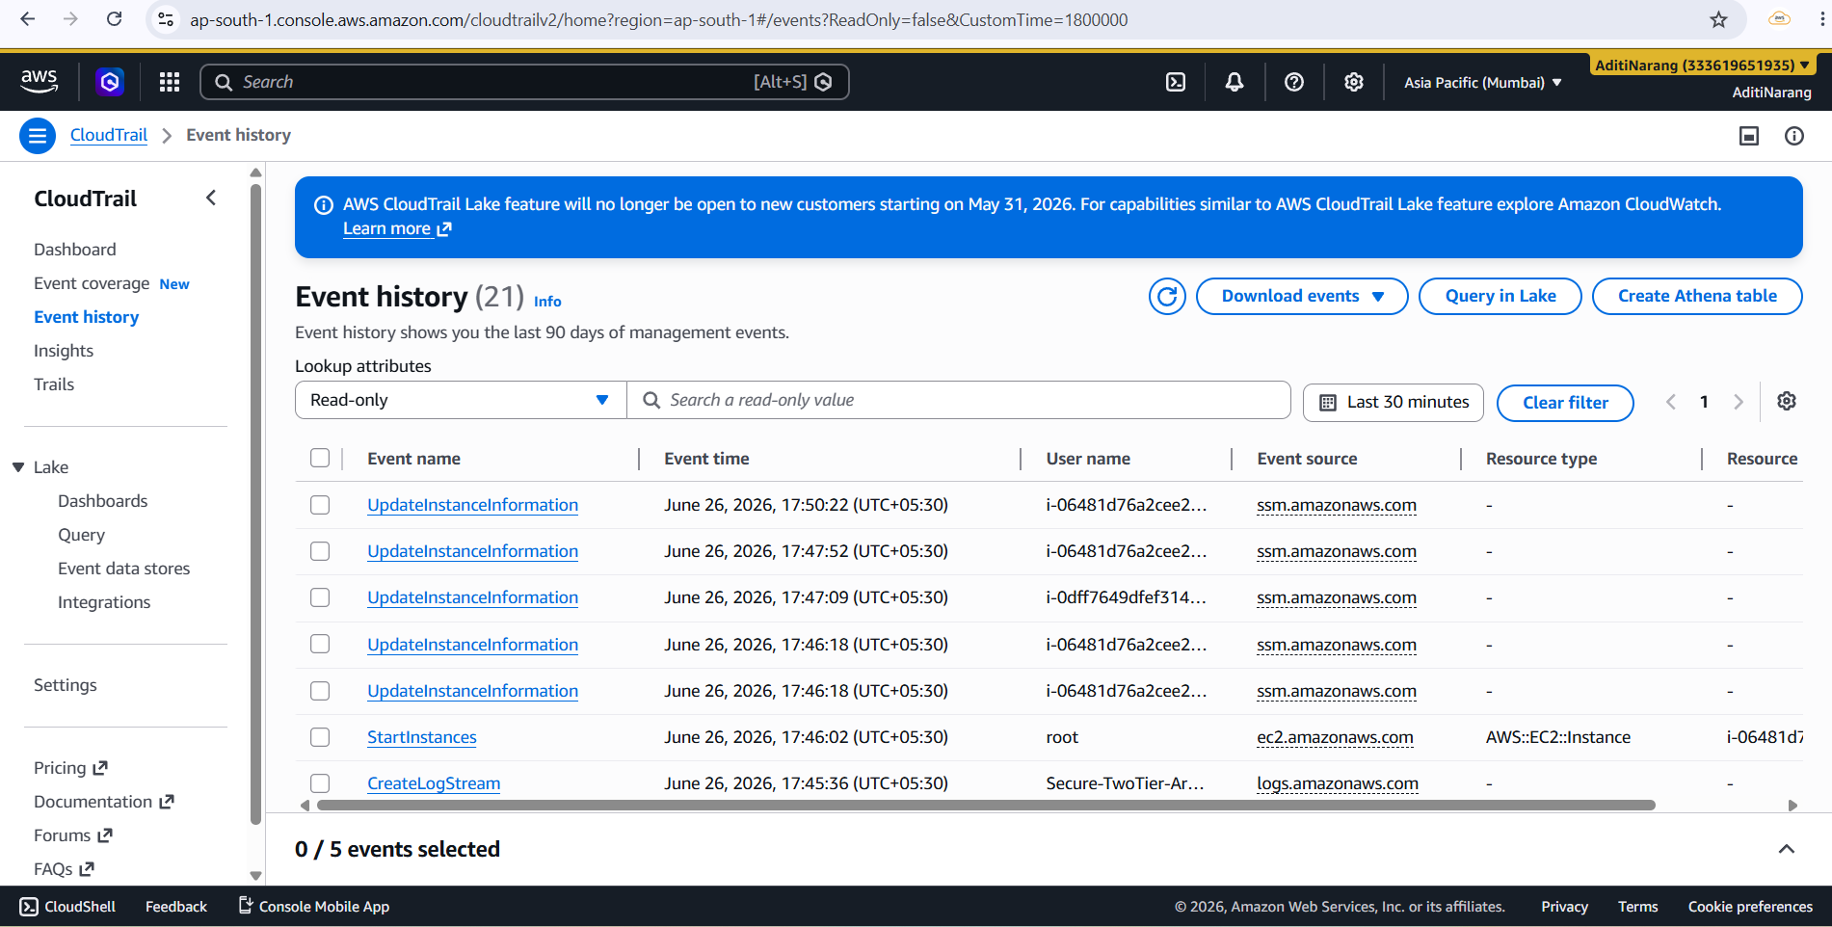

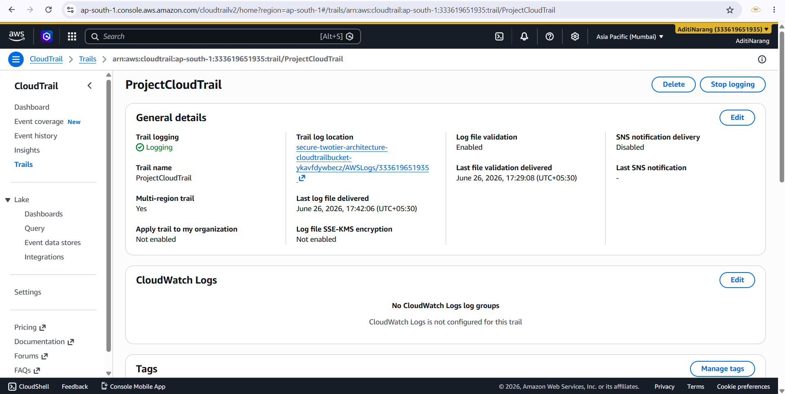

2.19 SNS:
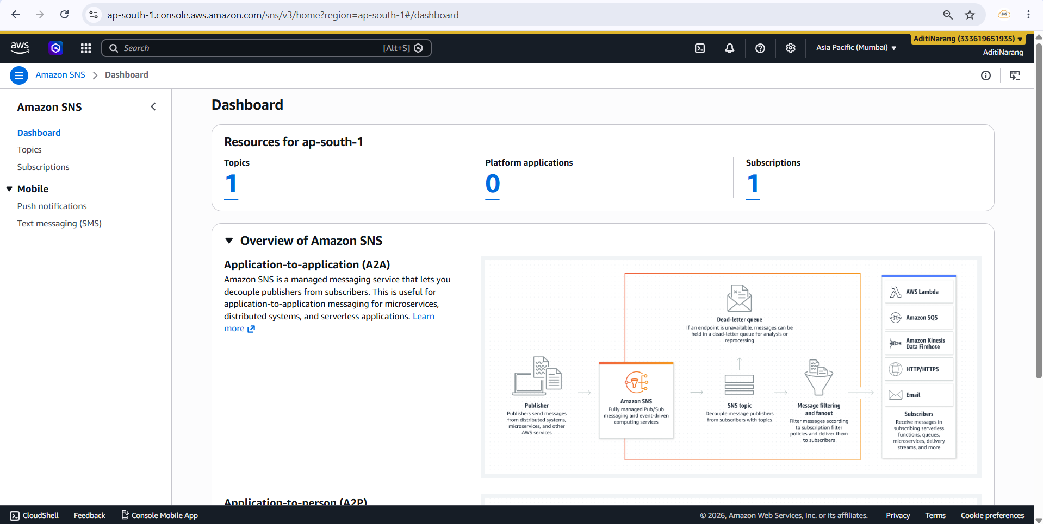

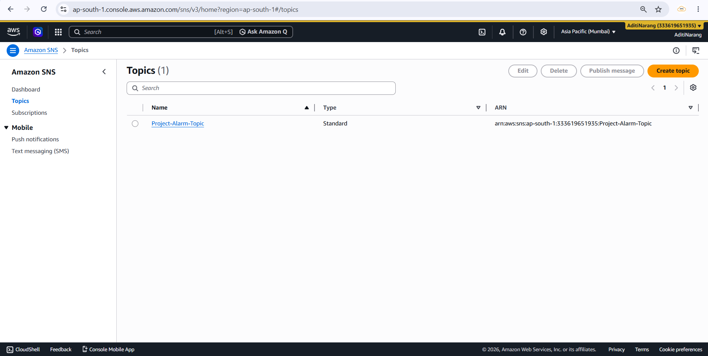

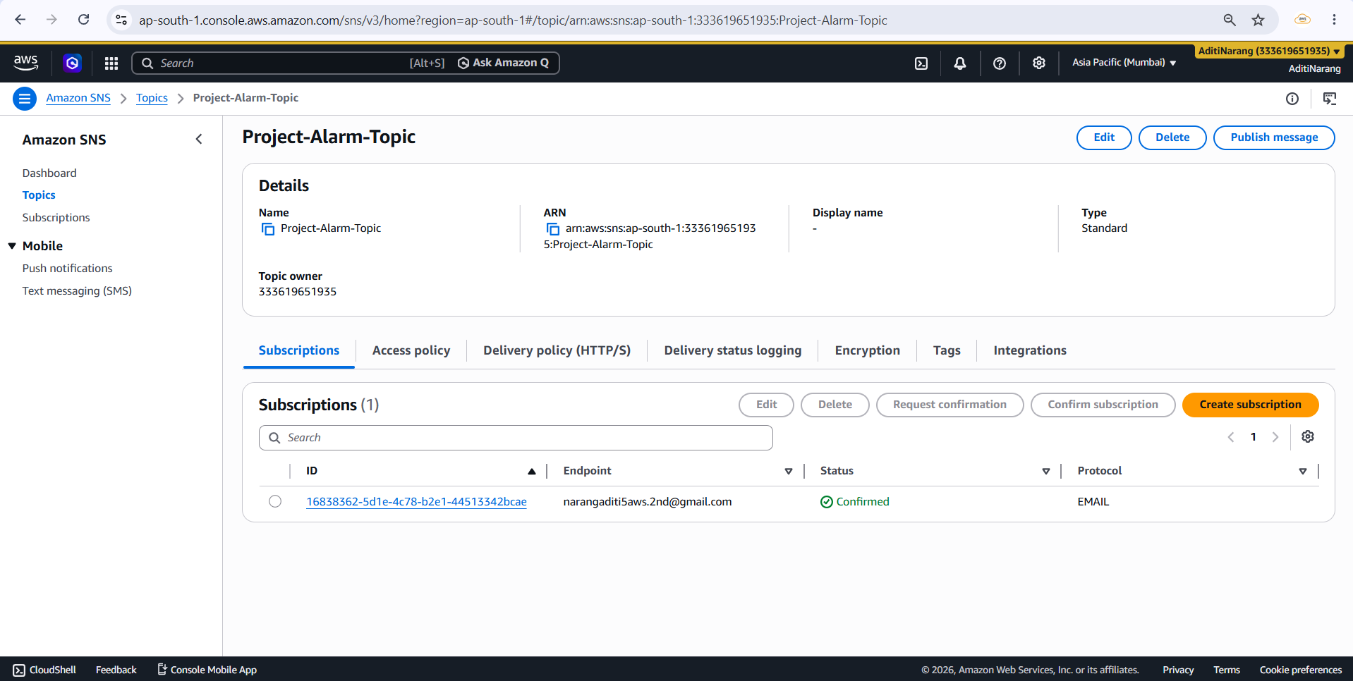
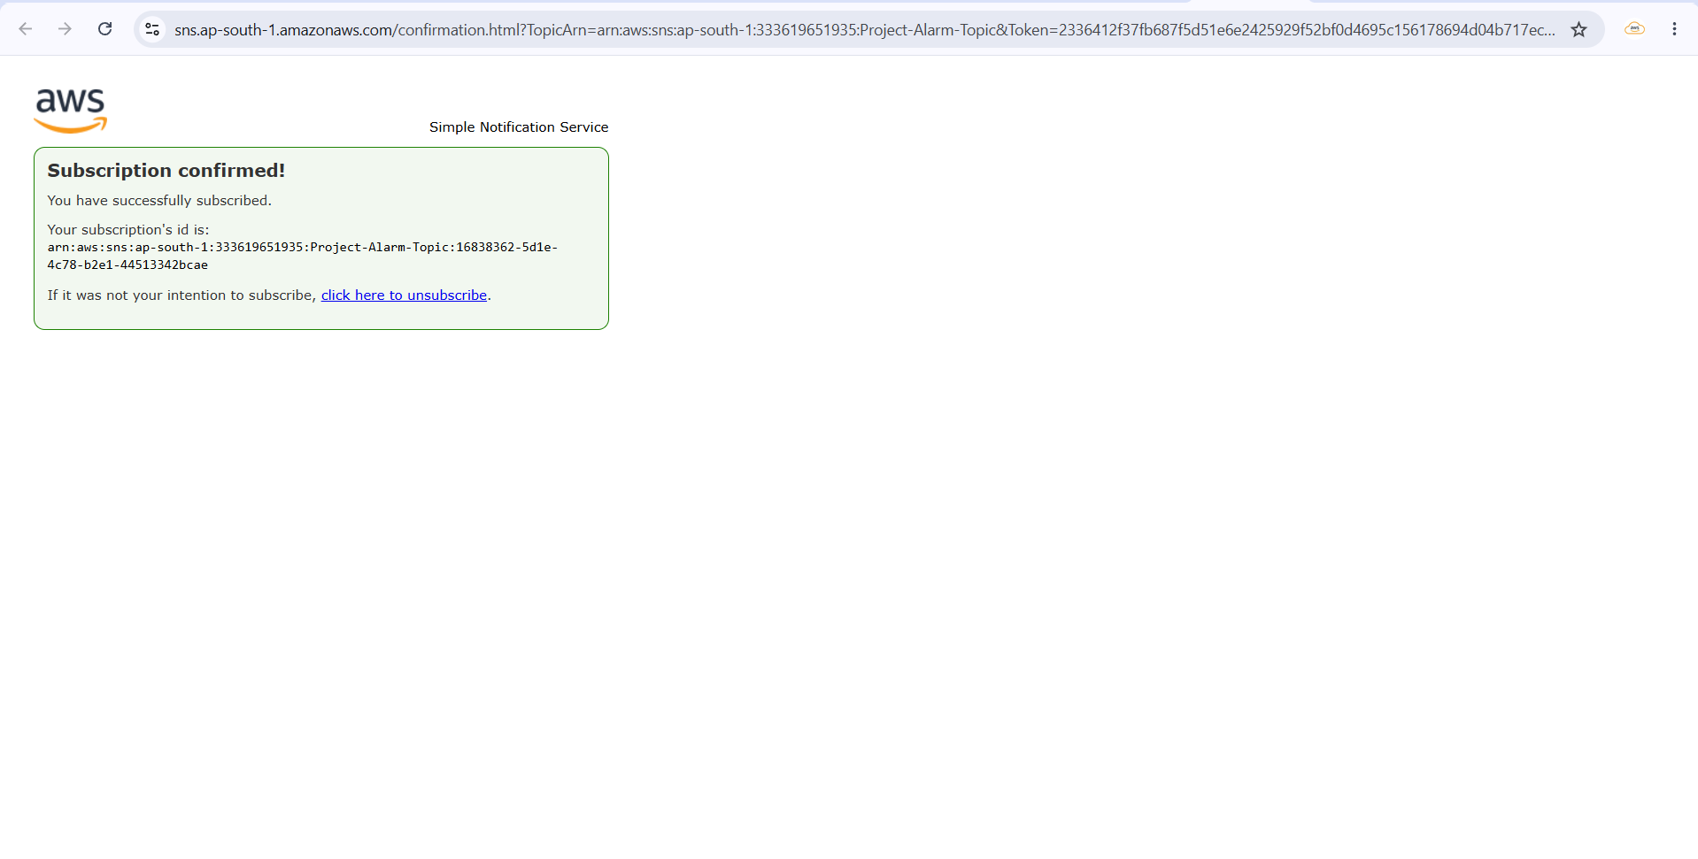
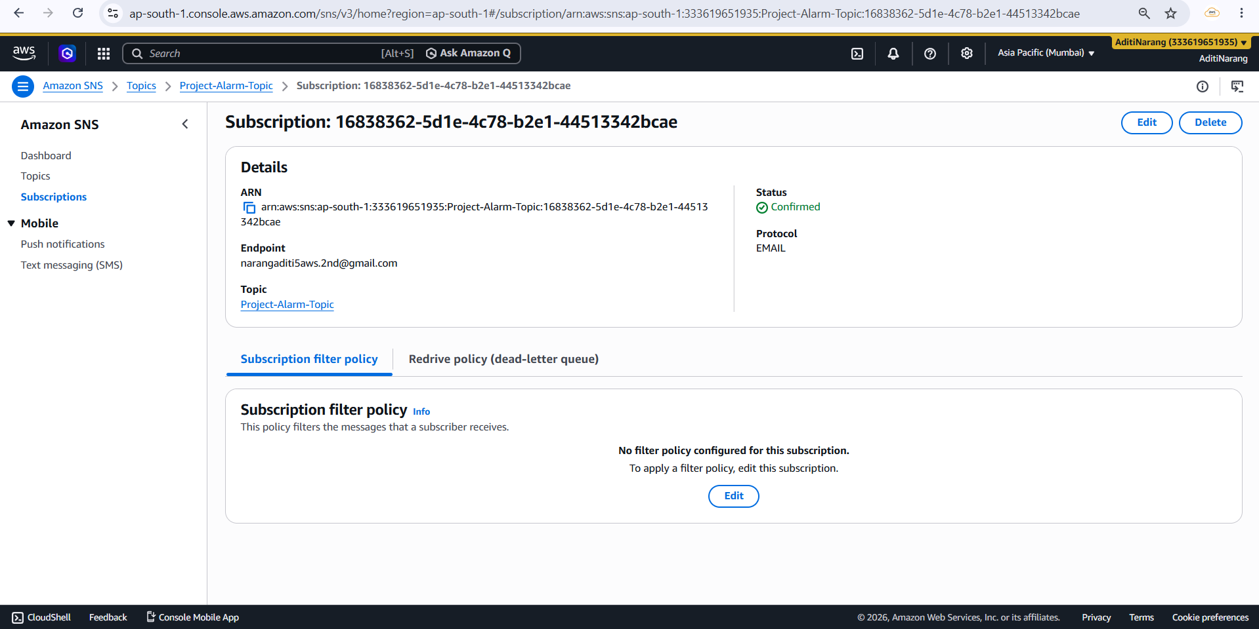

2.20 Alarm:
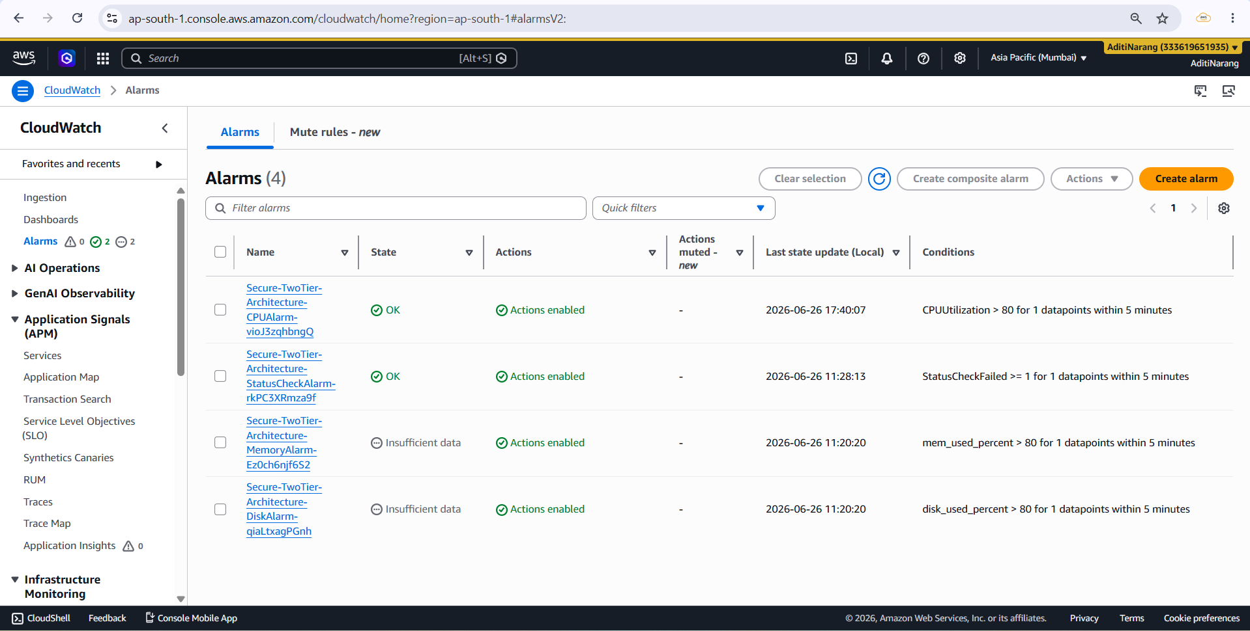

2.21 SNS Notification:
(Email)
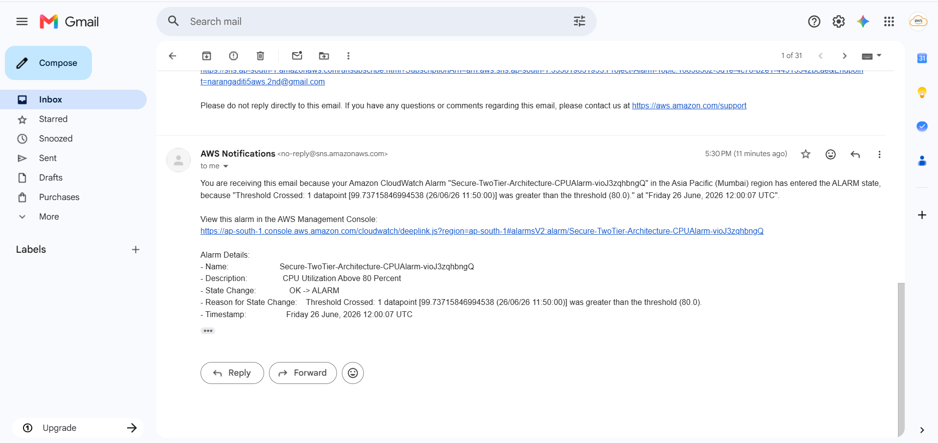

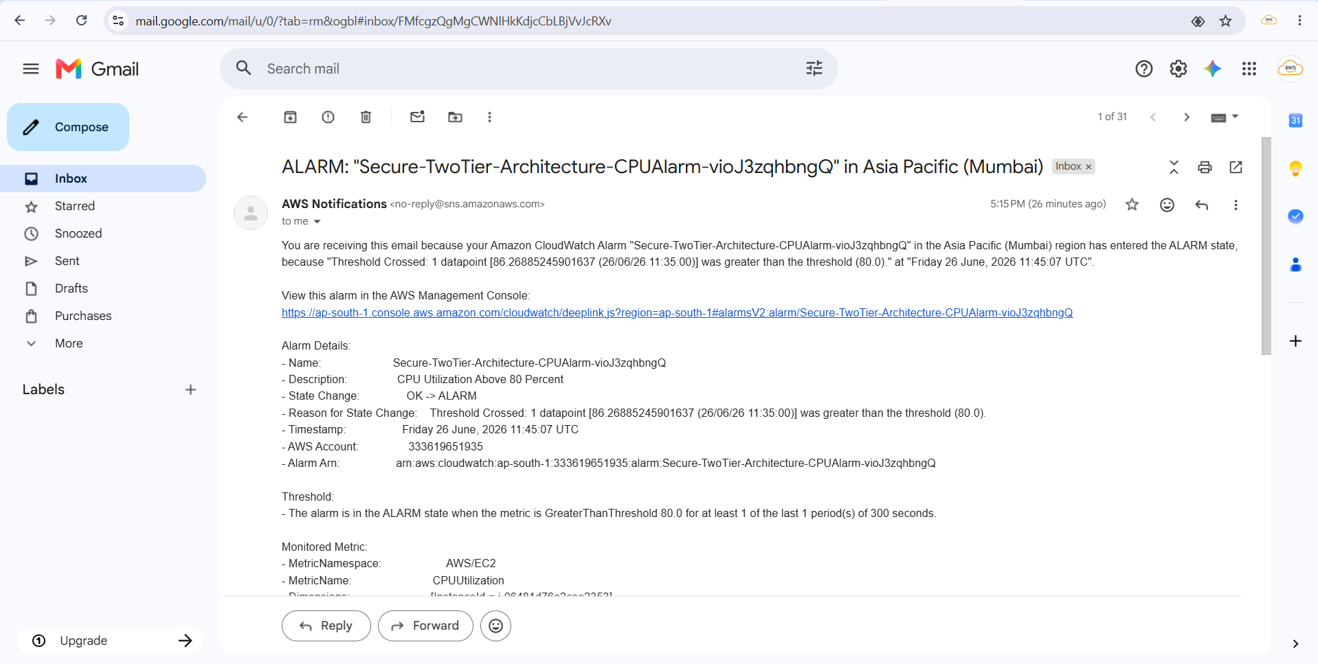

7. Conclusion
Successfully deployed a secure two-tier AWS infrastructure using AWS CloudFormation. The project demonstrates Infrastructure as Code, monitoring, logging, auditing, automated notifications, and backup capabilities. The deployment eliminates manual resource provisioning and provides a reusable, scalable, and production-oriented cloud architecture.

